OudhTrade
Product Requirements Document
V1 product scope and rules — R1 public web launch, R2 full web release, R3 mobile apps
Document details
Company | MRIDA INFRA AND PLANTATIONS LLP
Product | OudhTrade — oudhtrade.com
Scope | V1: R1 public web launch + R2 full web release (R3 apps via Module 19)
Related documents | BRD & Business Plan · HLD · module documents (8 per module) · traceability matrix
Product owner | [TBC: name]
Decision owner | T. Satish Reddy, CEO & Founder
Status | Draft for review — 23 September 2026
Classification | Confidential — for partners and the OudhTrade team

Contents
1. About This Document 4
1.1 Where the PRD sits 4
1.2 Scope 4
1.3 How to read requirements 4
2. Product Summary & Principles 5
2.1 Product principles 5
3. Users & Roles 6
3.1 External roles 6
3.2 Staff and partner roles 6
3.3 What each role can do 7
4. Platform-Wide Rules 10
5. Main User Journeys 11
5.1 Sign-up and verification 11
5.2 Listing lifecycle 12
5.3 Enquiry to confirmed trade and review 13
5.4 Requirement post to buy lead 14
5.5 Farmer onboarding by a field agent 15
5.6 Export deal 16
5.7 Scam report and enforcement 17
6. Requirements by Module 18
6.1 Module 1 — Platform Foundation 18
6.2 Module 2 — Identity & Security 19
6.3 Module 3 — Roles, Profiles & Verification 23
6.4 Module 4 — Taxonomy & Compliance Rules 29
6.5 Module 5 — Listings 30
6.6 Module 6 — Origin & Trade Documents 32
6.7 Module 7 — Search & Discovery 33
6.8 Module 8 — Requirements & Buy Leads 33
6.9 Module 9 — Messaging & Quotations 34
6.10 Module 10 — Reviews & Trust 35
6.11 Module 11 — Monetisation 36
6.12 Module 12 — Moderation & Compliance Operations 37
6.13 Module 13 — Notifications 38
6.14 Module 14 — Dashboards 39
6.15 Module 15 — Admin: Operations Console 39
6.16 Module 16 — Admin: Platform Configuration Console 40
6.17 Module 17 — Content & Legal 40
6.18 Module 18 — Analytics & Monitoring 41
6.19 Module 19 — Mobile Apps 41
6.20 Module 20 — Testing & Go-Live 41
7. Trust, Safety & Moderation Model 42
7.1 Trust score formula (defaults, all configurable) 42
7.2 Safety controls at a glance 42
8. Domestic vs Export & Compliance in the Product 44
8.1 Domestic and export trade 44
8.2 Legal and data-protection requirements 44
9. Monetisation Structure 46
10. AI Features & Rules 47
11. Non-Functional Requirements 48
12. Release Plan 49
12.1 Launch checks 49
13. Out of Scope for V1 50
14. Product Success Measures 51
15. Open Items & Assumptions 52
15.1 Assumptions 53
15.2 Module design inputs 53
Appendix A — Glossary 55
Appendix B — Requirement Summary 56
Appendix C — Working Sub-Category List 57

1. About This Document
This Product Requirements Document (PRD) defines what OudhTrade must do and the rules it must follow in Version 1 (V1). It is the single product baseline for the whole team — product, design, development, testing and operations.

1.1 Where the PRD sits
Document | Answers | Relationship to this PRD
BRD & Business Plan | Why we build it; market, business model, financials, go-to-market | Business goals and KPIs this PRD serves
PRD (this document) | What the product does; scope and rules | Product baseline
HLD and master database design | How it is built: architecture, technology, data model | Implements this PRD
Module documents (8 per module + diagram pack) | Detailed requirements (module FRS), backend, frontend, database, UX/UI, tests, success checklist | Break each PRD module into build-ready detail
Traceability matrix | Links each PRD requirement to module FRS items and test cases | Keeps everything connected

1.2 Scope
- V1 = R1 + R2 + R3. R1 is the public web launch (open sign-up worldwide), R2 the full web release (messaging, reviews, monetisation and the other R2 features), R3 the native iOS and Android apps. This PRD covers R1 and R2 as one complete specification; R3 is covered through the Mobile Apps module (Module 19).
- The development team sequences the work; each requirement carries the release in which it must first be available.
- Phase 2 and Phase 3 items are listed in Section 13 for context only; they are not V1 requirements.

1.3 How to read requirements
Field | Meaning
ID | PRD-<area>-<number>, e.g. PRD-LST-012. IDs are permanent; retired requirements keep their ID.
Priority | Must = required for the release to go live · Should = expected, can slip one release with product-owner approval · Could = nice to have if time allows
Release | R1 (public web launch ~month 3), R2 (full web release ~month 6–7), R3 (apps ~month 8–9). “R1→R2” means a basic version in R1 and the full version in R2.
Configurable | Numbers marked “configurable” are defaults set by Admin without code; the module FRS holds the default values.
[TBC: …] | Open item still to be decided (see Section 15).

The PRD states rules, not detailed fields, screens, database tables or APIs; those live in the HLD and module documents. When module tuning changes a rule, this PRD is updated in place.

2. Product Summary & Principles
OudhTrade (oudhtrade.com) is a global, B2B-first listing and discovery marketplace for the agarwood industry, connecting the full value chain — nurseries, farmers, inoculation providers, processors and distillers, traders and exporters, brands and buyers, and the supporting industry. It is operated by MRIDA INFRA AND PLANTATIONS LLP. Buyers and sellers find each other, talk and exchange quotations on OudhTrade; the deal, payment and delivery happen directly between them.

2.1 Product principles
# | Principle | What it means in the product
1 | Listing-only marketplace | No cart, checkout, escrow or payment between users. OudhTrade only bills its own subscriptions and ads.
2 | 0% commission — forever | No commission, success fee or deal-value charge of any kind.
3 | B2B-first, whole value chain | Selling roles are businesses (Farmers are individuals); buyers may be individuals or businesses. No Retail listing mode in V1.
4 | One global marketplace | One site for all countries, hosted in India; domestic and export trade handled differently.
5 | Trust first | Verification, confirmed-trade reviews, grading and origin documents, anti-scam controls. Paying never changes trust.
6 | Honest about limits | Documents are “on file — reviewed, not authenticated”; buyers do their own due diligence.
7 | Legal by design | CITES and export rules for export trade; plantation-only export; banned claims such as “wild”.
8 | AI-ready, human in control | AI helps search, moderation and writing; it never bans, verifies or changes trust on its own.
9 | Configurable, not hard-coded | Categories, permissions, limits, prices and texts are Admin-configurable with approvals and rollback.
10 | Web first, apps in V1 | Responsive web (desktop-first, mobile-friendly) first, then native apps — all within V1.

3. Users & Roles
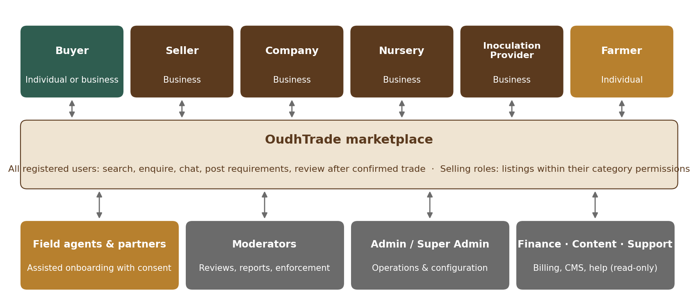
Figure 1 — External roles, staff roles and how they use OudhTrade

3.1 External roles
Role | Account type | Who | Can list
Buyer | Individual or business | Perfumers, attar and incense makers, traders, collectors | Nothing (enquiries and requirement posts only)
Seller | Business only (sole proprietors count) | Small trader selling a limited range; also labs, consultants, trainers, export agents and logistics firms | Limited product categories; Services (limited)
Company | Business only | Integrated plantation, processing, trading, export business; also farmer producer organisations (FPOs) and co-operatives, with a “Co-operative / FPO” badge | Almost all categories; Services (limited)
Nursery | Business only | Seedling and plant producer | Nursery categories; Services (limited)
Inoculation Provider | Business only | Inoculation service business | Inoculation services and limited listings; Services (limited)
Farmer | Individual only | Tree grower / plantation owner | Own produce, domestic only; seeds and plants with limits [TBC: Farmer limits]; no services

3.2 Staff and partner roles
Role | Purpose
Super Admin | Full control, including staff roles and high-impact configuration approvals
Admin | Operations and configuration within approvals
Moderator | Listing, document, report and campaign review (the verification team); enforcement. A Super Admin may give a Moderator the “Senior Moderator” flag (not a separate role) for escalations, revokes, repeat rejections and sanctions matches
Finance | Plans, invoices, refunds of OudhTrade charges, tax reports
Content Editor | Help centre, guides, market intelligence, legal page publishing
Support (read-only) | Helps users; may open ID-check cases, upload the ID photo or video a user sends and add notes; never approves, refuses or changes accounts
Field Agent | OudhTrade staff or approved partner who onboards Farmers with their consent; acts for a farmer only through a farmer-approved delegation (PRD-IDN-019)
OudhTrade Partner | Verified seller offering services (labs, export/CITES consultants) listed in the Partner Directory

3.3 What each role can do
Key: ✓ yes · V yes, after verification · L yes, with limits · C Admin-configurable (off unless enabled) · — no
Capability | Visitor | Buyer (Indiv.) | Buyer (Bus.) | Seller | Company | Nursery | Inoc. Prov. | Farmer
A. Discover
Browse, search, view listings & storefronts | ✓ | ✓ | ✓ | ✓ | ✓ | ✓ | ✓ | ✓
See prices (seller may choose “Sign in to see price”) | L | ✓ | ✓ | ✓ | ✓ | ✓ | ✓ | ✓
View Agarwood Opportunities (signed-in only) | — | ✓ | ✓ | ✓ | ✓ | ✓ | ✓ | ✓
Enquire on Agarwood Opportunities | — | V (ID check) | V | V | V | V | V | V
Shortlist, follow, saved searches, compare | — | ✓ | ✓ | ✓ | ✓ | ✓ | ✓ | ✓
Report a listing, profile or message | ✓ | ✓ | ✓ | ✓ | ✓ | ✓ | ✓ | ✓
B. Buy
Enquire, chat, request quotation or sample | — | L | ✓ | ✓ | ✓ | ✓ | ✓ | ✓
Post requirements | — | L | ✓ | ✓ | ✓ | ✓ | ✓ | ✓
Request a listing’s documents | — | ✓ | ✓ | ✓ | ✓ | ✓ | ✓ | ✓
Confirm “We traded” and review | — | ✓ | ✓ | ✓ | ✓ | ✓ | ✓ | ✓
Optional verification badge | — | ID check | Business | — | — | — | — | —
C. Sell
Create draft listings | — | — | — | ✓ | ✓ | ✓ | ✓ | ✓
Publish listings (within category permissions) | — | — | — | V | V | V | V | V + L
Services listings (Category 5) | — | — | — | V + L | V + L | V + L | V + L | —
“Export available” listings (export credentials) | — | — | — | V | V | V | V | —
Bulk upload and bulk edit | — | — | — | V | V | C | C | —
Opportunity listings | — | — | — | C | V | C | V (inoc. partner­ships) | V (own trees & land)
Receive enquiries (can filter buyers) | — | — | — | V | V | V | V | V
Send quotations | — | — | — | V | V | V | V | V
Receive and answer buy leads | — | — | — | V | V | V | V | V + L
Storefront page | — | — | — | V | V | V | V | Simple profile
Website link on profile | — | — | — | V | V | V | V | —
Link to upstream sources (origin chain) | — | — | — | V | V | C | C | As a source, with consent
Listing done by a field agent | — | — | — | R1 free; paid from R2 | R1 free; paid from R2 | C | C | ✓ free
D. Plans and programmes
Paid subscription plans | — | — | — | ✓ | ✓ | ✓ | ✓ | C
Advertising | — | — | — | V | V | V | V | C
Founding Seller programme | — | — | — | ✓ | ✓ | ✓ | ✓ | C
Apply to the Partner programme | — | — | — | V | V | V | V | —
Referral programme | — | ✓ | ✓ | ✓ | ✓ | ✓ | ✓ | ✓

- Every account can buy: all selling roles also have every buyer ability.
- Before verification, selling roles can use buyer features, save drafts and submit listings for review; submitted listings wait and go live automatically when the account is verified (PRD-ROL-005). Quotations, buy leads, advertising and export listings need verification (“Business verified”, or “Verified farmer” for Farmers).
- One account has one role, one profile and one member in V1 (team members come later). The exact role is chosen on the sign-up form (PRD-ROL-001); role changes are upgrades only (for example Buyer → Seller or Seller → Company), requested by the user and decided by Admin (PRD-ROL-009).
- Services (Category 5): there is no separate service-provider role. Seller, Company, Nursery and Inoculation Provider can list services with limited listing options set in the role-to-category table (PRD-TAX-005); labs, consultants, trainers, export agents and logistics firms join as a Seller (or Company) offering services. Farmers do not list services.
- Opportunities: any signed-in user can view them; sending an enquiry on an Opportunity needs an ID check (individual buyers) or business / farmer verification. Business selling roles need the enhanced check to post Opportunities (PRD-ROL-028). Farmers do not take the enhanced check: a Farmer’s Opportunity listings of their own trees and land rely on “Verified farmer” plus land papers on the listing (Modules 5 and 6).
- Individual buyers have a daily enquiry limit (default 10) and a smaller requirement-post allowance. Sellers can choose to receive enquiries from business buyers only or verified buyers only.
- Farmers list domestic only in V1, use the free plan only (paid plans and ads configurable, off by default), and get field-agent help free.
- “C” cells are set in the Admin-configurable permission table (PRD-TAX-005). Final category limits, including Farmer limits, are set in listing-module tuning [TBC: Farmer limits].

4. Platform-Wide Rules
These rules apply to every module. A module requirement may never break them.
ID | Requirement | Priority | Release
PRD-GEN-001 | OudhTrade never processes, holds or routes payments between users and never charges commission on deals. | Must | R1
PRD-GEN-002 | Users’ phone numbers, emails and addresses are never shown publicly; contact happens through OudhTrade messaging until users choose to share details (subject to the trust-based limits in Module 9). | Must | R1
PRD-GEN-003 | Paying for a plan or advertising never changes trust level, review display, search trust weighting or moderation standards. | Must | R1
PRD-GEN-004 | All paid placements are labelled “Ad” or “Sponsored” (chosen per placement type in Admin, always visible, translated); the label is built in R1 and used from the first paid placement (R2). | Must | R1
PRD-GEN-005 | Documents are shown as “on file — reviewed, not authenticated”; the word “verified” is used only for identity checks (Business verified, Verified farmer, Verified buyer), never for documents. | Must | R1
PRD-GEN-006 | Every listing, requirement post, review, campaign and profile text passes the automatic check before it is visible; flagged items go to human review. | Must | R1
PRD-GEN-007 | Claims that are banned platform-wide: “wild” origin, medicinal or cure claims, “guaranteed pure” without a lab report on file, and any claim listed in the Admin-managed banned-claims list. | Must | R1
PRD-GEN-008 | Every Admin, Moderator, Field Agent and AI action on user data or content is written to an append-only audit log kept for 7 years. | Must | R1
PRD-GEN-009 | AI never bans, verifies, approves documents or changes trust by itself; AI output that users see is labelled. | Must | R1
PRD-GEN-010 | All limits, weights, time windows and texts named “configurable” in this PRD are editable by Admin without code, with change history. | Must | R1
PRD-GEN-011 | Users must be 18 or over; sign-up requires an “I am 18 or over” declaration (no date of birth collected). | Must | R1
PRD-GEN-012 | Prices are set in INR for India-based sellers and USD for all others, including Agarwood Opportunities; the platform does not convert listing prices, but shows a guide price in the viewer’s currency (PRD-FND-013). | Must | R1
PRD-GEN-013 | The platform never states or implies that NRIs or foreigners can buy agricultural land, and never promises returns on any listing. Investment schemes, deposit schemes and offers of shares or other securities are prohibited content. | Must | R1
PRD-GEN-014 | Retired categories, items, plans or rules are never deleted; they are retired so history remains readable. | Must | R1
PRD-GEN-015 | MRIDA INFRA AND PLANTATIONS LLP does not sell on OudhTrade; staff with trading interests must declare them and cannot moderate related content. | Must | R1

5. Main User Journeys
These journeys show how the requirements fit together end to end. Each module document expands them into detailed flows and screens.

5.1 Sign-up and verification
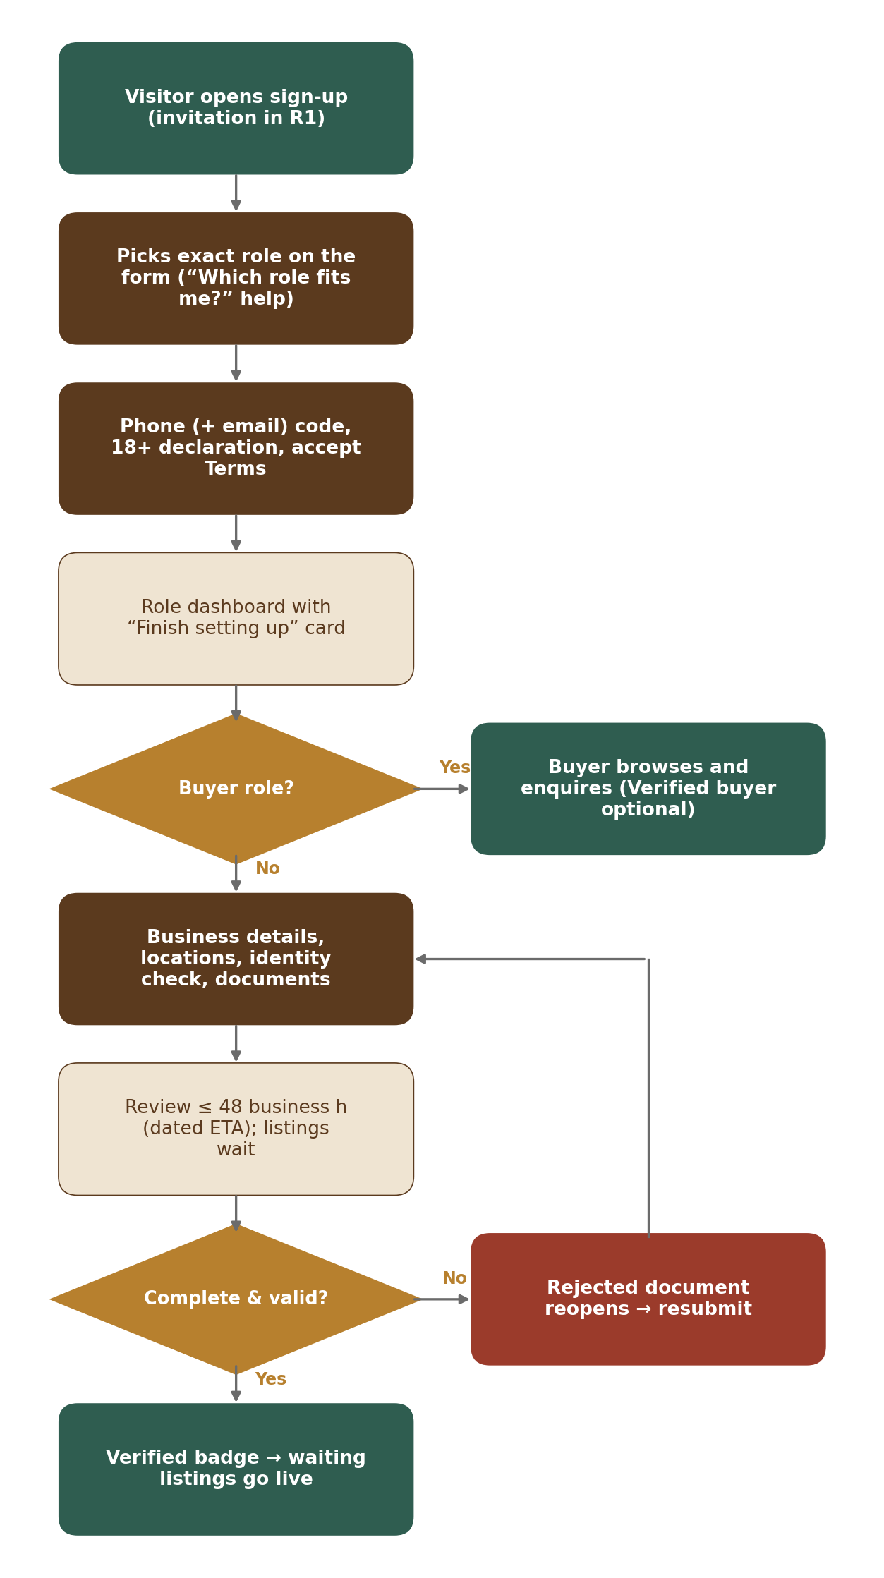
Figure 2 — Sign-up and verification

5.2 Listing lifecycle
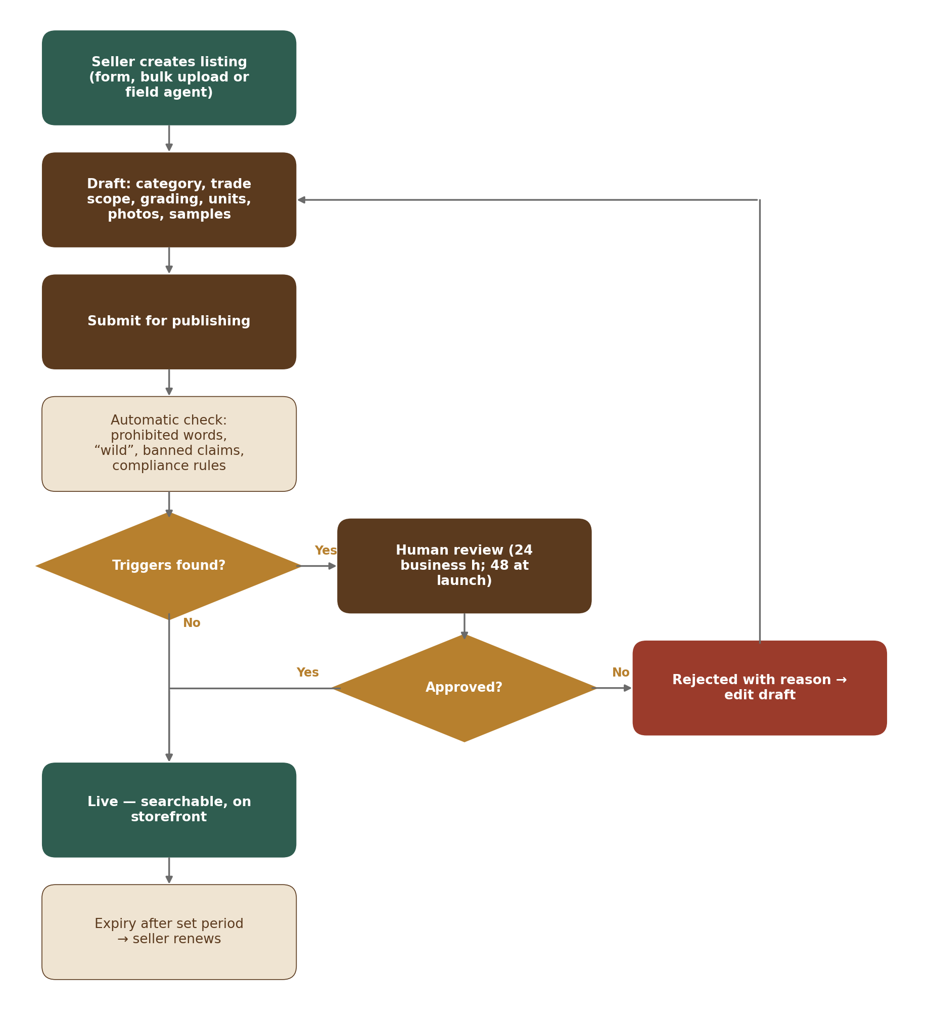
Figure 3 — Listing lifecycle

5.3 Enquiry to confirmed trade and review
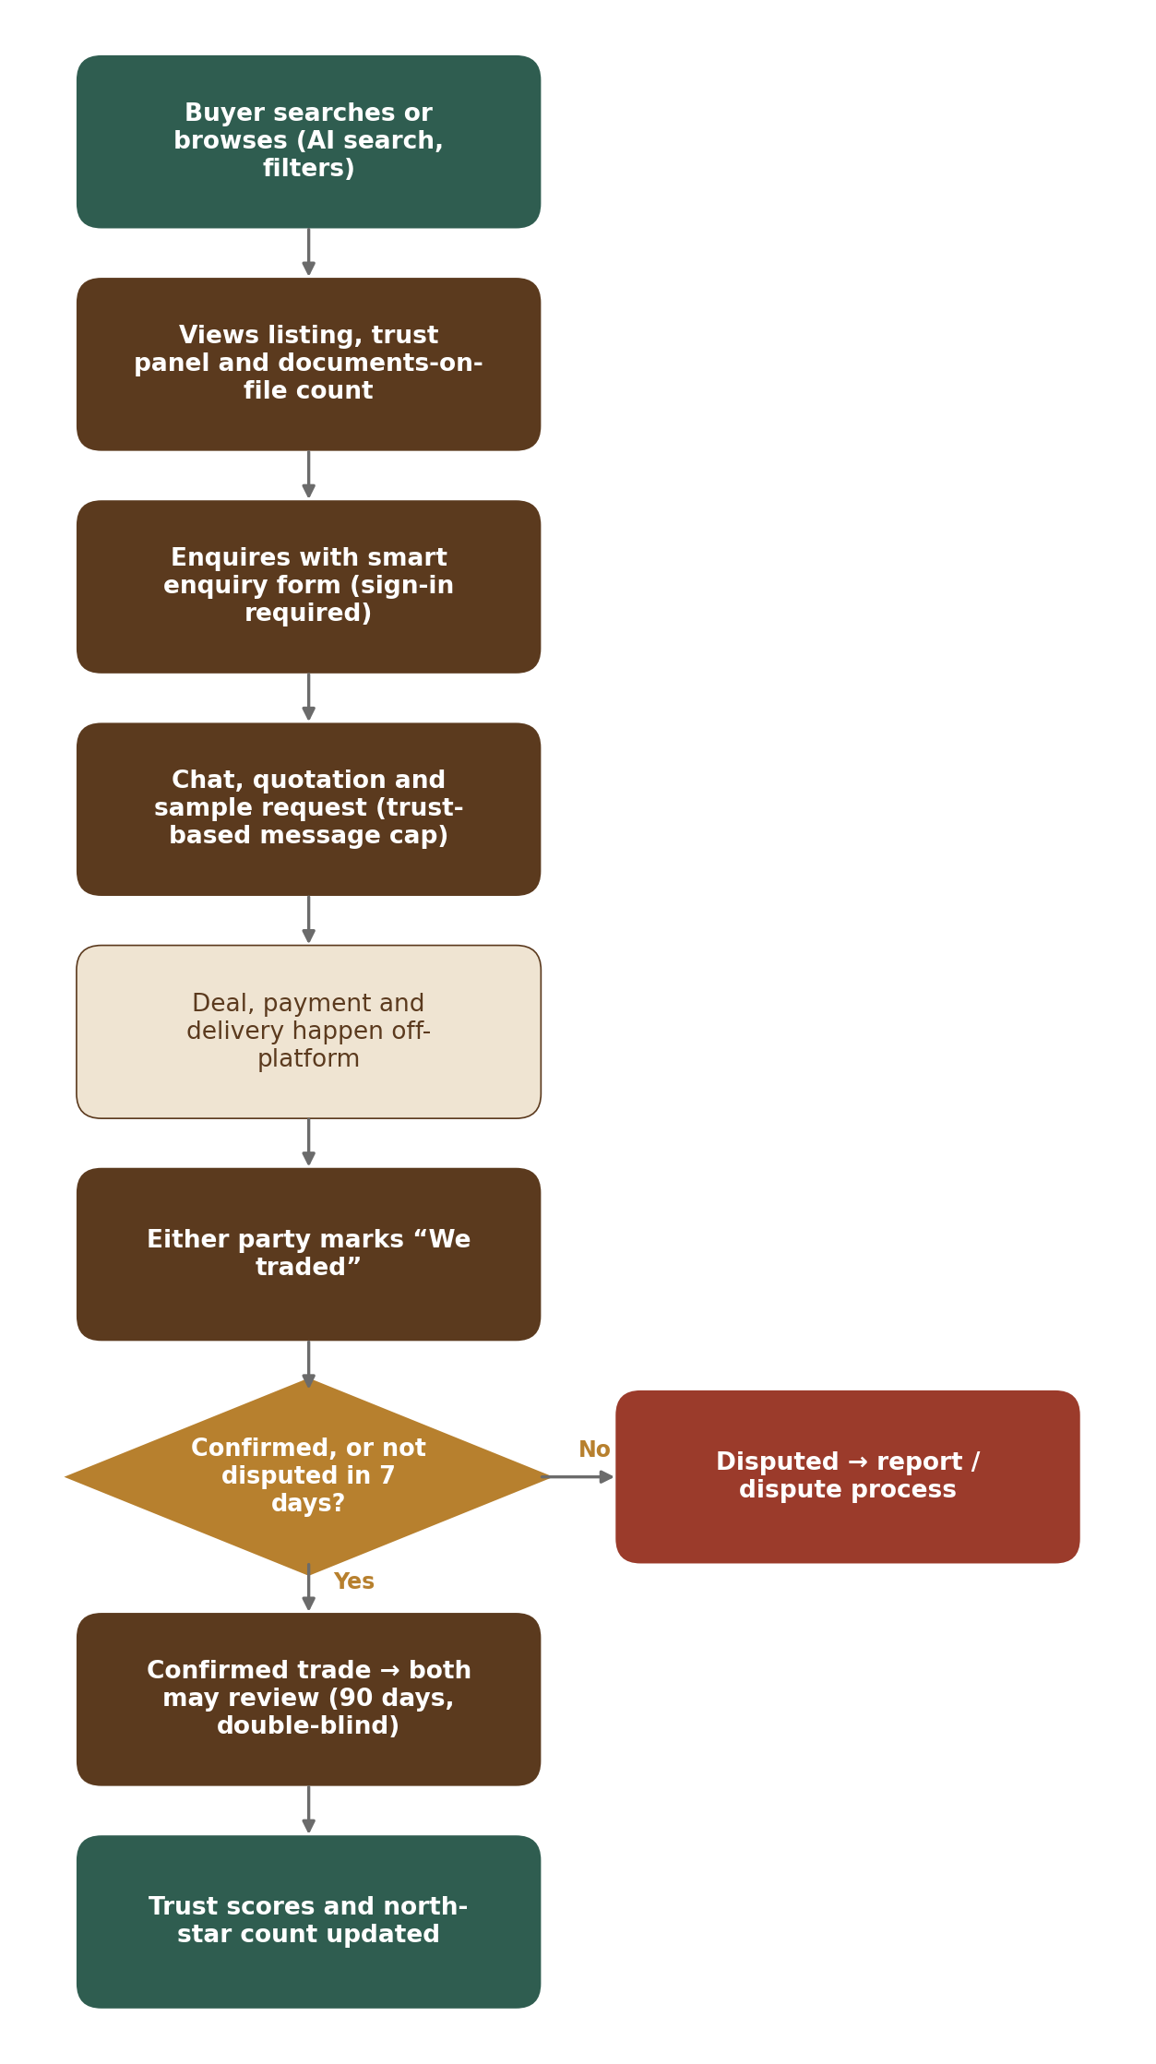
Figure 4 — Enquiry to confirmed trade and review

5.4 Requirement post to buy lead
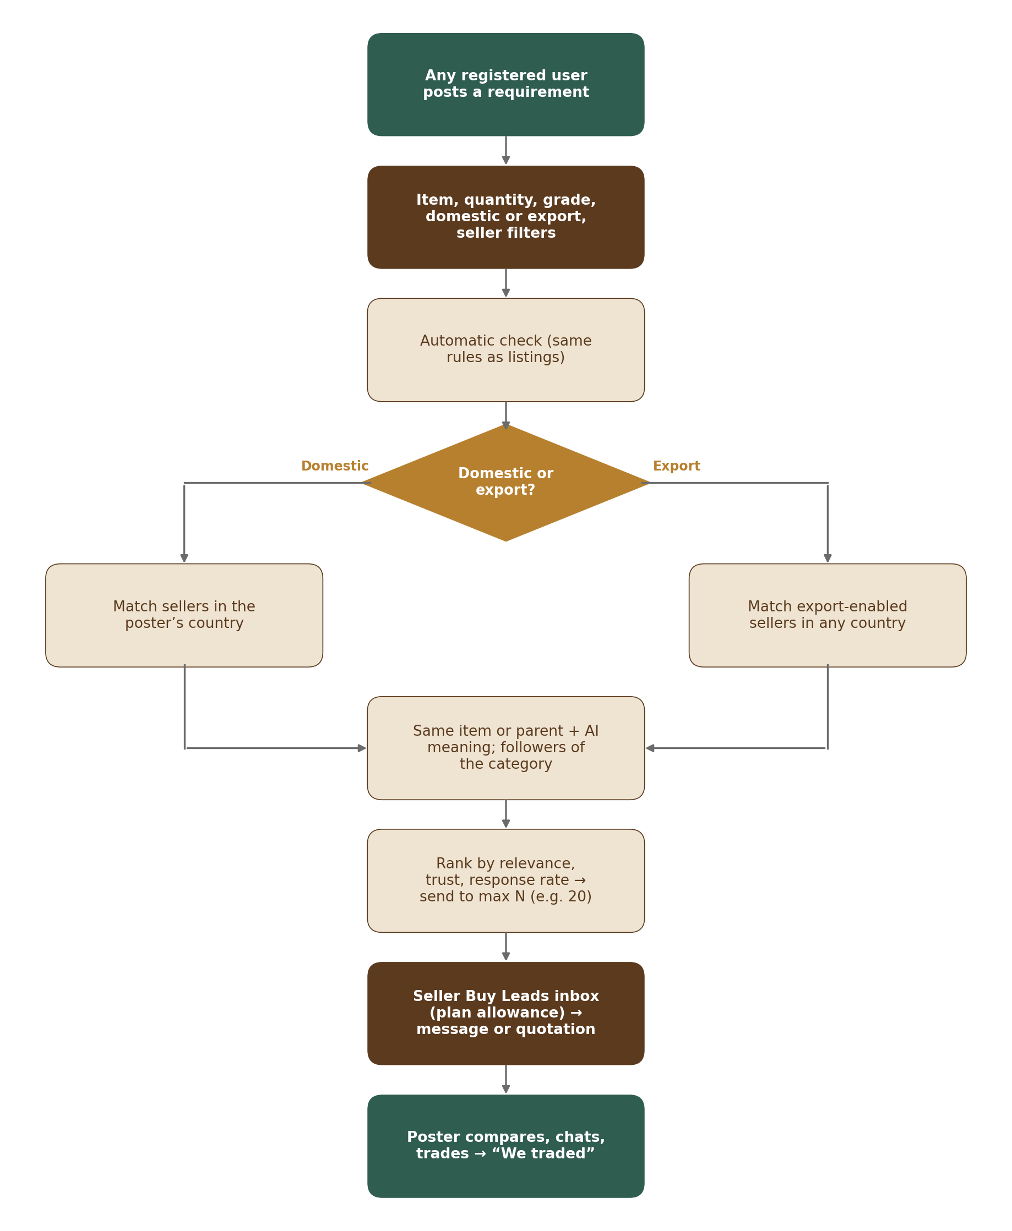
Figure 5 — Requirement post to buy lead

5.5 Farmer onboarding by a field agent
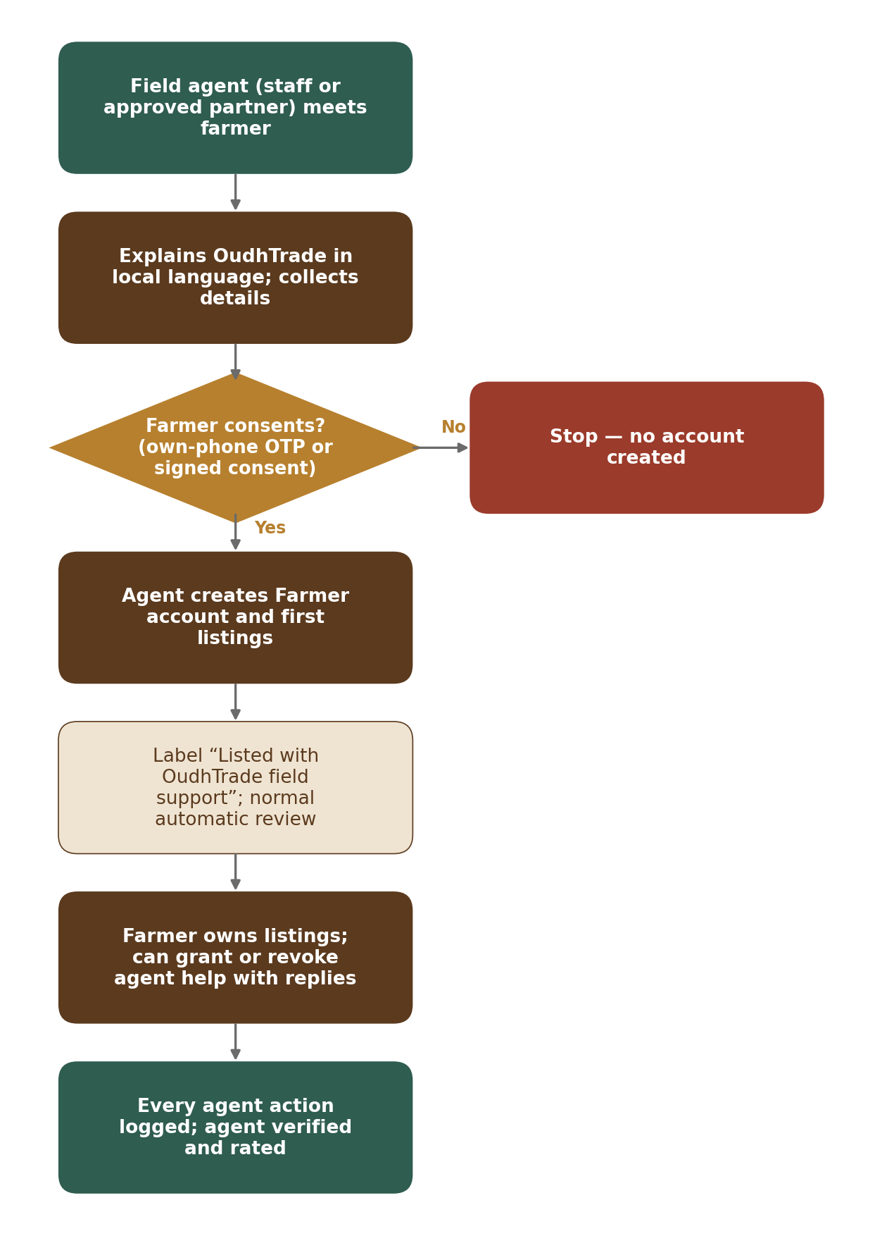
Figure 6 — Farmer onboarding by a field agent

5.6 Export deal
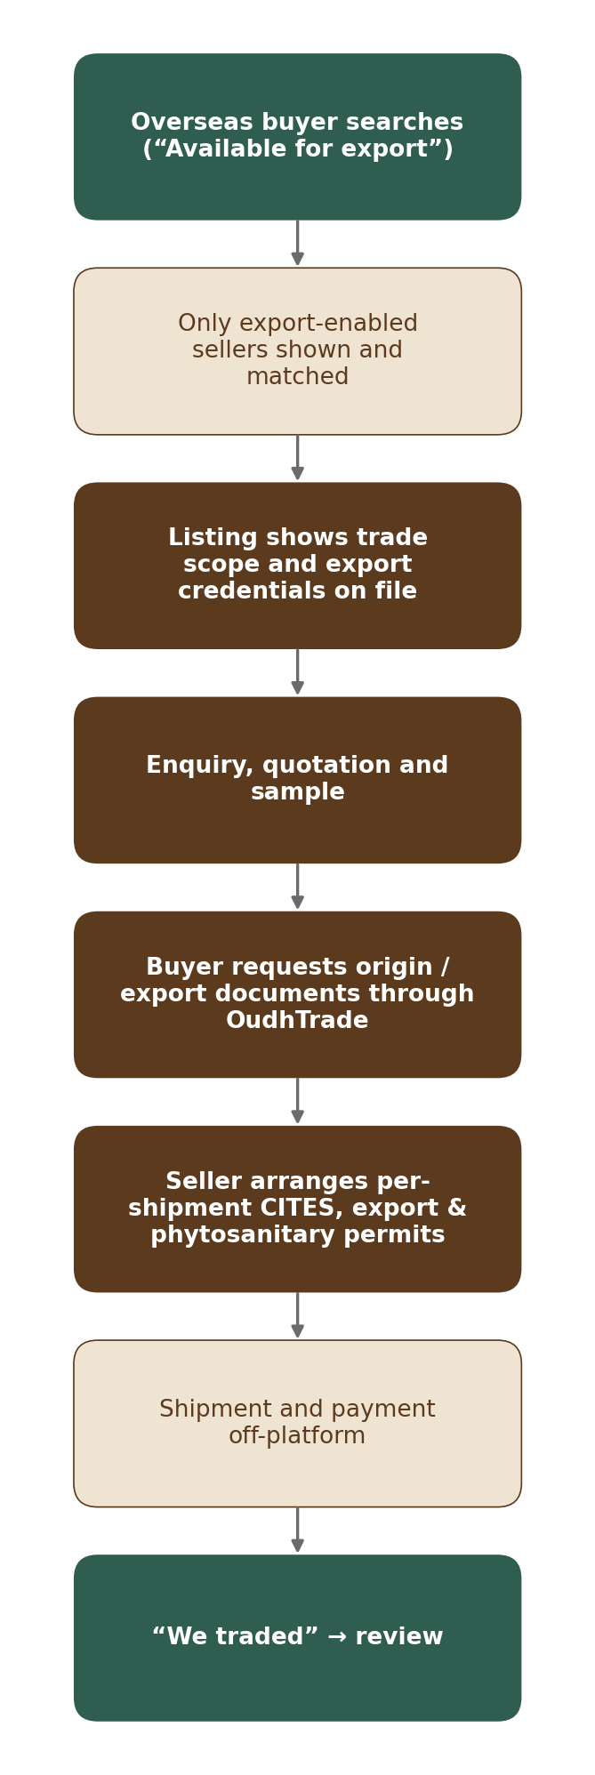
Figure 7 — Export deal

5.7 Scam report and enforcement
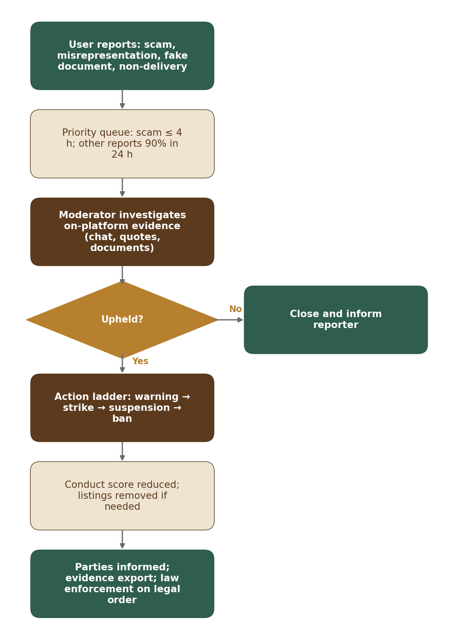
Figure 8 — Scam report and enforcement

6. Requirements by Module
V1 is built as 20 modules. Each module below states its purpose, its PRD-level requirements and what is deliberately left for later. Detailed rules, fields and screens are in each module’s documents.
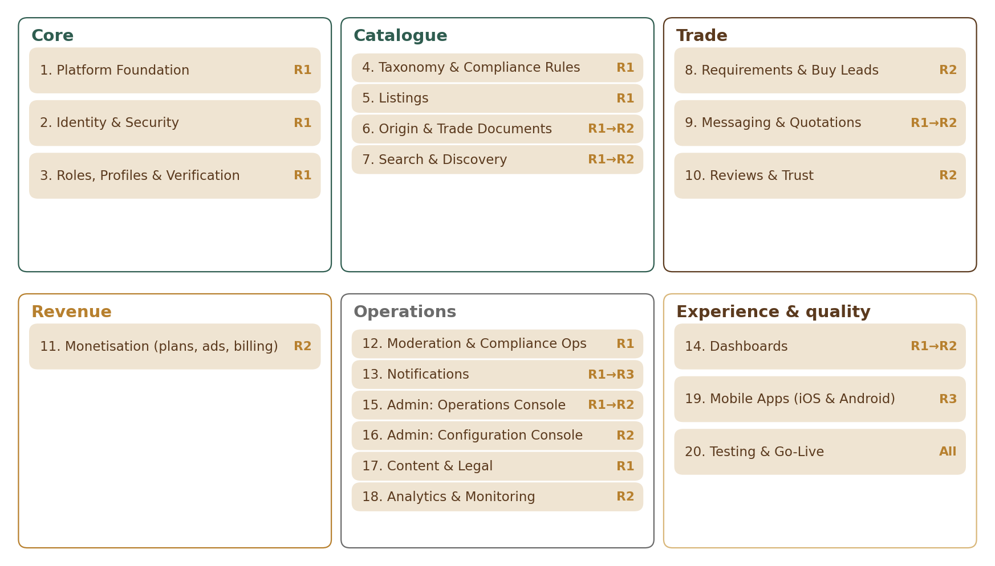
Figure 9 — The 20 V1 modules and their first release

6.1 Module 1 — Platform Foundation
Shared base for all modules: environments, core services, file handling, photo safety, units, languages, country and currency reference, rate limits, edge security and the audit log.
ID | Requirement | Priority | Release
PRD-FND-001 | Separate development, staging and production environments; configuration can be exported from staging and imported to production. | Must | R1
PRD-FND-002 | Single global web application served worldwide through a CDN, with the main platform hosted in India (Mumbai) and a warm standby database and backups in a second Indian region (Hyderabad). | Must | R1
PRD-FND-003 | API-first: every user and admin function the web uses is available through secured APIs, so apps and future AI agents use the same rules. | Must | R1
PRD-FND-004 | File uploads: photos JPG, PNG, WEBP and HEIC up to 15 MB (reduced automatically); documents PDF, JPG, PNG, HEIC / HEIF and WEBP up to 10 MB (HEIC, HEIF and WEBP converted for reviewers); video MP4 or MOV up to 100 MB (all configurable); every file is malware-scanned before storage or display. | Must | R1
PRD-FND-005 | Photos have location and device metadata removed before public display; the private original keeps location for origin checks by staff with the verification permission only, with every view logged. | Must | R1
PRD-FND-006 | All user-facing text is stored in a translation store; English at launch; layout supports right-to-left languages (Arabic) without redesign. | Must | R1
PRD-FND-007 | Append-only audit log for sensitive actions, retained 7 years and searchable by Admin. | Must | R1
PRD-FND-008 | Standard unit list with Admin-configurable factors. Prices are entered and shown per metric or count unit (g, kg, ml, litre, piece…); traditional units are shown only as helpers: tola 11.66 g (wood) or 12 ml (oil), mithqal 4.25 g, seer, maund; bigha and katha by state for land (Legal Metrology Act 2009 — counsel to confirm). | Must | R1
PRD-FND-009 | Time shown in the user’s local time zone; operational service targets measured in IST business hours. | Must | R1
PRD-FND-010 | Public pages (listings, storefronts, guides) are search-engine friendly: clean URLs, sitemaps, structured data; private and Opportunity pages are not indexed. | Should | R1
PRD-FND-011 | Cookie and tracking consent banner; analytics beyond essential cookies only with consent. | Must | R1
PRD-FND-012 | Architecture keeps a white-label option possible later without rework (no white-label feature in V1). | Must | R1
PRD-FND-013 | Guide price: under the listing price, the price is also shown in the viewer’s currency (e.g. “≈ AED 270, guide only”) using daily exchange rates; never used for sorting, billing or quotations; the viewer can switch it off. | Must | R1
PRD-FND-014 | One shared Country table (phone code, currency, language, time zone, address layout, status, allowed features) used by all modules; any setting can be overridden by country, category, plan or role. | Must | R1
PRD-FND-015 | One shared rate-limit service for all modules (per visitor, account and plan); web application firewall with bot and anti-scraping protection; sanctioned countries blocked at the edge; security headers; CERT-In time-sync and 6-hour incident reporting. | Must | R1
PRD-FND-016 | Photos showing phone numbers, emails, payment IDs, web addresses or QR codes are held for moderation; photos copied from other sellers are flagged. | Must | R1

6.2 Module 2 — Identity & Security
Sign-up, sign-in, sessions, account states and security controls for users and staff.
ID | Requirement | Priority | Release
PRD-IDN-001 | On the sign-up form the user picks the exact role (Buyer — individual or business, Seller, Company, Nursery, Inoculation Provider or Farmer; PRD-ROL-001); when the person signs up through an invitation (field agents, FPOs and the OudhTrade team, PRD-IDN-014), the invited role is pre-filled. Sign-up needs a mobile number (everyone) and an email address (buyers and business sellers; optional for farmers onboarded by a field agent), each confirmed by a one-time code (OTP); 18+ declaration; separate agreement lines (Terms of Use, Privacy Notice, consent to data processing and the other required lines — M02-2 SUP-031), each stored with its version. When the Terms or Privacy Notice change materially, users accept the new version at their next sign-in. | Must | R1
PRD-IDN-002 | Sign-in with mobile number or email plus password, or with Google or Apple (PRD-IDN-015). A normal sign-in needs no code; an extra OTP is asked only when the sign-in looks risky (PRD-IDN-016). No OTP-only sign-in. Password rules: at least 10 characters, breached-password check, no forced periodic change, paste and password managers allowed; passwords stored with Argon2id. Farmers set their own simple password at onboarding; the field agent never sees it. | Must | R1
PRD-IDN-003 | All staff and partner accounts — Super Admin, Admin, Moderator, Finance, Content Editor, Support (read-only), Field Agent and OudhTrade Partner — use two-step sign-in: password plus an authenticator app (no SMS codes). Super Admin and Finance also use a passkey or security key. Staff sign in separately from users, and the Admin app is reached only through the VPN or an IP allow-list. | Must | R1
PRD-IDN-004 | Optional authenticator-app two-factor for users. | Should | R1
PRD-IDN-005 | Sessions: users stay signed in up to 30 days on their own device; a “public device” choice ends the session when the browser closes; sensitive actions ask again for the password or a code. Staff sessions end after 30 minutes idle or 12 hours at most. Access tokens are short-lived; refresh tokens change on every use, and reuse of an old one signs out every session of that account. Users can sign out of one device or all devices (times configurable). | Must | R1
PRD-IDN-006 | Account states: active, deactivated (by the user, reversible), dormant (12 months idle, PRD-IDN-018), suspended (by staff, with a reason), banned, closed. Deactivated and dormant accounts hide listings; deactivated accounts pause expiry clocks. Suspended and banned users see the reason and an appeal link (appeals are handled in Module 12). | Must | R1
PRD-IDN-007 | Account closure by the user: a 30-day grace period in which the user can come back; after it, personal data is anonymised, legally required records are kept, and the user is informed. | Must | R1
PRD-IDN-008 | Users can download their own data (profile, listings, messages, reviews) on request. | Must | R1
PRD-IDN-009 | Brute-force protection by soft lock: after 5 failed sign-ins, a bot check and growing delays apply and the attacker’s IP address or device is blocked, not the account. The account is locked only after 20 failures, and the owner gets an unlock link by email or SMS. OTP entry and sending are rate-limited (details in the module FRS). | Must | R1
PRD-IDN-010 | Bot check (AWS WAF CAPTCHA, with an accessible alternative) on sign-up, invitation, account recovery and risky sign-ins, and on enquiry and requirement forms. Throw-away email addresses (Admin-managed list of disposable email domains) are refused; internet (VoIP) phone numbers are flagged for staff review. | Must | R1
PRD-IDN-011 | Security messages (sign-in codes, new sign-in, password, phone or email change) are sent through the Notifications module’s high-priority “send now” route with delivery tracking; they are always sent and cannot be switched off. | Must | R1
PRD-IDN-012 | Role-based permissions enforced on the server for every action; staff permissions assigned by Super Admin only, and granting admin rights needs a second approver. Staff access is reviewed every quarter; two sealed emergency Super Admin accounts exist; access is removed the same day a staff member leaves. | Must | R1
PRD-IDN-013 | Sign-ups, listings and enquiries are blocked from comprehensively sanctioned countries; the country list is Admin-configurable and set with counsel in line with cloud and payment-provider terms [TBC: sanctions list]. The sign-up check uses the declared account country, the phone-number country and the IP country (PRD-IDN-023). | Must | R1
PRD-IDN-014 | Open sign-up worldwide from R1: anyone can sign up without an invitation. Invitations are kept for field agents (farmers), FPOs (member farmers) and the OudhTrade team: each invitation carries the role it allows, which is pre-filled on the sign-up form, and a “This isn’t my role” link lets the invited person ask for a correction. The code arrives in the invitation link (there is no code field on the sign-up form; the landing page accepts a code received by SMS or voice call). Invitation links are single-use, valid 14 days and tracked (who invited whom); guessing of invitation codes is rate-limited. | Must | R1
PRD-IDN-015 | Google and Apple sign-in from R1. After it, the user still confirms a mobile number by OTP. A Google or Apple sign-in is never linked to an existing account just because the email matches: the user signs in with password (and OTP) first, then links it. Google sign-in is hidden in countries where Google is blocked (for example China). | Must | R1
PRD-IDN-016 | Risk-based OTP: an extra code is asked on a new device or new country, after many failed tries, and for sensitive changes (phone, email, password, account country). “Remember this device” for 30 days means no risk code on a known device. | Must | R1
PRD-IDN-017 | Tiered account recovery: forgot password → code to phone or email; lost phone → email code and password, then a 72-hour wait with alerts to old and new contacts; no email or password (farmers) → identity check by a field agent or support. Authenticator-app users get 10 backup codes. Recovery of verified sellers is also reviewed by staff. Answers never reveal whether an account exists. | Must | R1
PRD-IDN-018 | Recycled phone numbers: if an account has been idle 90 days or more, a password reset by phone code alone is not enough (an email code, or for farmers a field-agent or support identity check, is also needed). After 12 months idle the account becomes dormant: listings are hidden, reminders are sent by email and SMS, and reactivation needs a full re-check. | Must | R1
PRD-IDN-019 | Field-agent assisted sign-up: the agent fills the form, the farmer confirms with an OTP on the farmer’s own phone and sees the consent in simple words; the consent is stored with the agent’s ID; the agent never controls the account. The farmer can give a field agent limited rights for 30 days, approved with a code. In R1 the rights are only: edit listing drafts (listing_draft_edit), upload photos (photo_upload), edit the farmer profile and “Your trees” (farm_profile_edit; Away mode, PRD-ROL-045, is added to this right when it arrives in R3), and upload verification documents and farm-visit reports (verification_upload; land papers are added later to the farmer’s listings, Modules 5 and 6). Nothing else in R1. The agent never submits anything for review for the farmer without the farmer’s code confirmation; the farmer approves each listing before it goes live and can cancel at any time; every agent action is logged with both names. | Must | R1
PRD-IDN-020 | Nominee: a user can name a nominee to act for them if they die or cannot act (DPDP Act right) [TBC: nominee details and proof, counsel]. | Must | R1
PRD-IDN-021 | Data requests: download of own data within 7 days (JSON, CSV and a readable PDF summary); corrections within 7 days; deletion after a 30-day grace period (PRD-IDN-007). Request timers are tracked [TBC: deadlines confirmed by counsel (C10)]. | Must | R1
PRD-IDN-022 | Under-18 user found: the account is suspended at once and its listings hidden, the person is told, and personal data is deleted after checks (legally required records kept). Only the 18+ declaration is collected. | Must | R1
PRD-IDN-023 | Account country: the user declares it; it is checked against the phone-number country and the IP country; differences are allowed but noted. Changing the account country later needs an OTP and is logged. | Must | R1
PRD-IDN-024 | Sanctions name screening: business and export sellers are screened by name against sanctions lists (UN and lists named by counsel) during verification in Module 3, using a screening service [TBC: service]. | Must | R2
PRD-IDN-025 | Account-takeover risk checks: alerts on a new device or country, extra OTP when a sign-in looks unusual, mass password guessing blocked, security events sent to monitoring. Users see their devices and sign-in history and can sign out one device or all; the “This wasn’t me” link in every security alert locks the account at once and starts recovery. | Must | R1
PRD-IDN-026 | Ban-evasion signals: new sign-ups are compared with banned accounts on a few hashed signals (device, phone and email patterns, IP, document numbers); a match is flagged for staff review, never blocked automatically; explained in the Privacy Notice; signals kept only as long as needed. | Should | R1
PRD-IDN-027 | Optional passkeys for users (the password stays available). | Should | R2
PRD-IDN-028 | Partner and AI-agent access: approved partners, and later AI agents acting for a user, get API access with limited scopes, a user consent screen, expiry, key rotation, revoke and their own rate limits. | Should | R2
PRD-IDN-029 | Per-country OTP channels and sign-in methods come from the shared Country table (India, in this order: SMS with DLT templates, voice-call codes in Hindi, Assamese, Bengali and English, WhatsApp, then email; a farmer may type the code on the field agent’s handover screen when needed; outside India: WhatsApp first, then SMS; email always as backup). Codes are sent only to allowed countries, with a daily OTP cost cap per country and alerts on spikes (protects against SMS pumping). Codes fill in automatically on phones; paste is allowed. | Must | R1
PRD-IDN-030 | Removed (24 Sep 2026): there is no waitlist; sign-up is open to everyone from R1 (PRD-IDN-014). | Must | R1
PRD-IDN-031 | Anti-phishing: every code message says “OudhTrade will never ask for this code”; official staff messages carry an official “OudhTrade Team” badge that users cannot copy; a public page lists the official OudhTrade channels. | Must | R1
PRD-IDN-032 | Support access: staff can never sign in as a user. Support gets a read-only view of an account, must give a reason, and every view is logged. | Must | R1
PRD-IDN-033 | Consent purposes (marketing email; marketing SMS; marketing WhatsApp; personalised promotions — personalised sponsored placements, used from R2; optional analytics cookies; AI help on my own listings) are stored separately and can be withdrawn in Settings. | Must | R1
PRD-IDN-034 | One mobile number = one account; one email = one account. A field agent never uses their own number for a farmer. | Must | R1
PRD-IDN-035 | Recycled-number reclaim: when a new owner of a mobile number signs up and the number belongs to an account idle 90 days or more, the new owner proves the number by code; the old account is told by email; after 7 days with no objection the number is released, and the old account adds a new number at its next sign-in. | Must | R1
PRD-IDN-036 | Sign-up resilience: in-app browsers (inside social and chat apps) are detected and the user is offered the normal browser; sending the sign-up form again is safe (no duplicate account); if the bot check is unavailable a fallback challenge is used (never skipped); typed values are kept after an error. | Must | R1
PRD-IDN-037 | Reminders for unused invitations and unfinished sign-ups (a small, configurable number, by email or SMS). | Must | R1
PRD-IDN-038 | Suspended and banned users keep their data rights — download their data, withdraw consent, ask for correction and raise a grievance — and a suspended user sees the date the suspension ends. | Must | R1
PRD-IDN-039 | “My account – personal details” page (name, photo, preferred language, time zone) and a “Change password” page. | Must | R1

Later (not V1): WeChat sign-in (China) if demand grows. Signing in as a user (impersonation) is not planned; support uses a read-only view (PRD-IDN-032).

6.3 Module 3 — Roles, Profiles & Verification
Role choice at sign-up, role dashboards with the “Finish setting up” card, business profiles, identity and business verification, the enhanced check, farmer verification and farm visits, role changes and assisted onboarding by field agents.
ID | Requirement | Priority | Release
PRD-ROL-001 | The exact role (Buyer, Seller, Company, Nursery, Inoculation Provider or Farmer) is chosen on the sign-up form; when a person signs up through an invitation, the invited role is pre-filled (PRD-IDN-001, 014). A public, shareable “Which role fits me?” page gives full information on every role — who it is for, what it can do, its limits and one line on what it needs to get verified — with a table comparing all roles. The same content opens as a pop-up from the role step of the sign-up form (a side panel on desktop, a full-screen sheet on phone); choosing a role there picks it and keeps what the user has typed. The exact documents for each country are shown only in the Documents step of setup (PRD-ROL-027). | Must | R1
PRD-ROL-002 | Account types: Buyer = Individual or Business; Seller, Company, Nursery, Inoculation Provider = Business only; Farmer = Individual only. | Must | R1
PRD-ROL-003 | Small traders are guided to a simple business registration (e.g. Udyam in India) before becoming sellers. | Must | R1
PRD-ROL-004 | Business verification: required documents configured per role and country, using per-country checklists (PRD-ROL-027); completeness review (type, legible, name match, not expired) within 48 business hours (P95), shown to the user as a dated expected decision (ETA). Verification states: not started, pending, verified, rejected with reason, resubmitted, expired, on hold and revoked (PRD-ROL-029). | Must | R1
PRD-ROL-005 | Listings go live only for Business-verified or Verified-farmer accounts. While verification is pending, sellers can save drafts and “submit for review”; submitted listings wait in “Waiting for your verification” and go live automatically when the account is verified. A verified business shows a “Business verified” badge. Automated registry checks (e.g. GST, Udyam, MCA) are used where available (PRD-ROL-024). | Must | R1
PRD-ROL-006 | Document expiry: expiry comes from the document’s own date, otherwise from a validity per document type (e.g. business documents 24 months); reminders 60, 30 and 7 days before expiry. On expiry, new publishing is paused and the badge is removed; live listings stay for 30 days (configurable grace period), then are hidden (never deleted) and come back on renewal. Registrations without an expiry date (GSTIN, Udyam, CIN) are not uploaded again; a monthly registry status check is used instead, and re-verification happens only when something changes. | Must | R1
PRD-ROL-007 | Individual buyers: email + phone OTP, labelled “Individual buyer”, configurable daily enquiry limit (default 10) and smaller requirement-post allowance; optional ID check for a “Verified buyer” badge. | Must | R1
PRD-ROL-008 | Sellers can choose to receive enquiries from “business buyers only” or “verified buyers only”. | Must | R1
PRD-ROL-009 | Role change: only upgrades are allowed — Buyer → any selling role (Seller, Company, Nursery, Inoculation Provider or Farmer), Farmer → Seller, and Seller, Nursery or Inoculation Provider → Company; there are no step-downs (e.g. Company → Seller) and no Farmer → Company directly (the list of paths is an Admin setting). The user requests the new role and completes that role’s setup and documents; Admin decides within 48 business hours (never automatic); the old role stays active until approval; listings not allowed in the new role go back to draft (never deleted). One open request at a time. A buyer who asks for a selling role is reviewed as one case: a Moderator checks the documents and identity and recommends, and Admin decides the role and the verification together; buyer features, interests and history are kept. Buyer Individual → Business is self-service. | Must | R1
PRD-ROL-010 | Public business profile (trust facts): store (trading) name with the legal business name next to it, role, city/state/country, country of registration, “Business verified · date”, each public registration (in India: GSTIN, CIN / LLPIN, Udyam and IEC) as type with a masked number and its status (e.g. “GSTIN 18AAB•••1ZM · active”; PAN is private and never shown), member since, trust level, “Replies within 24 hours” (the one seller reply measure), languages, year established, business size band, short bio and description, capabilities, badges, business locations with site type and site label and contact hours (PRD-ROL-043), website and social links (PRD-ROL-034) and a grievance / report link. Contact details (phone, email) always stay private: buyers contact the seller through OudhTrade messages [TBC: C14 — the EU Digital Services Act (Art. 30–31) may require a trader’s contact details to be shown to EU consumers; until counsel answers, contacts stay private]. The exact address and map pin stay private. Farmers show a public display name they choose and their district, and, if they add them, tree type, tree count range and tree age (labelled “self-declared”, PRD-ROL-037) and their working days and hours (“Usually available …”); the village stays private. | Must | R1
PRD-ROL-011 | Field agents (staff or approved partners) can create a Farmer account and listings only with the farmer’s consent, confirmed by an OTP on the farmer’s own phone (PRD-IDN-019). | Must | R1
PRD-ROL-012 | Listings created by a field agent are labelled “Listed with OudhTrade field support”; ownership stays with the farmer; agents cannot change prices without farmer approval. | Must | R1
PRD-ROL-013 | Farmers can grant and revoke delegated access for a field agent (scope and rules in PRD-IDN-019); every agent action is logged; agents are verified and rated. | Must | R1
PRD-ROL-014 | Optional badges: “Women-led enterprise” (self-declared, with optional evidence) and “Co-operative / FPO” (for Company accounts that are farmer producer organisations or co-operatives, checked during verification; they can confirm their member farmers, PRD-ROL-032). The profile badge list has 12 badges (Glossary, “Badge”), including “GST registered” (PRD-ROL-041) and “Trusted” (PRD-ROL-042); “Export permitted” is a listing badge (PRD-ORG-013). Admin can add new staff-awarded badges without a code release (PRD-ROL-046). “Verified” is used only for identity and business checks. | Should | R1
PRD-ROL-015 | Founding Seller badge (permanent) for the first sellers verified after R1 (Founding Seller programme, PRD-MON-004); no invitation is needed. | Must | R1
PRD-ROL-016 | OudhTrade Partner programme: partners apply, Admin verifies, “OudhTrade Partner” badge and Partner Directory; partners can be removed on upheld complaints. | Must | R2
PRD-ROL-017 | Farmer verification checks the farmer’s identity only, by either route: (a) an ID check (PRD-ROL-026); or (b) in-person confirmation by a field agent or an FPO — the agent sees the farmer’s ID and signs a declaration, and the farmer confirms with a code on their own phone (PRD-ROL-032). No land or plantation proof is asked for at onboarding: land papers, plantation and origin proofs, lab reports and certificates of origin are added to listings (Modules 5 and 6). Agent- and FPO-confirmed farmers are spot-checked (PRD-ROL-031). The result is shown as a “Verified farmer” badge (identity verified), required before a Farmer’s listings go live. | Must | R1
PRD-ROL-018 | Business buyers can optionally complete business verification for a “Business verified” badge; it is not required to enquire or post requirements. | Must | R1
PRD-ROL-019 | Before verification, selling roles can use all buyer features, save draft listings and submit them for review (they wait and go live when verified, PRD-ROL-005); nothing they create is public. Quotations, buy leads, advertising and export listings require verification. | Must | R1
PRD-ROL-020 | One account has one role; every role, including selling roles, can also buy. | Must | R1
PRD-ROL-021 | V1: one account has one profile and one member; team members come later. | Must | R1
PRD-ROL-022 | Farmer simple mode: farmer screens use larger buttons, fewer steps and simple words, and work on slow 3G connections. | Must | R1
PRD-ROL-023 | After sign-up and every sign-in, users land on their role dashboard. R1 has three basic dashboards: Buyer home, the seller-side dashboard (Seller, Company, Nursery, Inoculation Provider) and a simple Farmer dashboard (Module 14 adds statistics, plan panels and ads from R2). A “Finish setting up” card lists what is left in two groups — “Required to publish” and “Recommended for trust” (never a percentage); “Continue setup” opens the setup step for the next unfinished item, every step can be saved to finish later, and nothing blocks exploring. | Must | R1
PRD-ROL-024 | Business details: the user first chooses the country of registration (not pre-selected; the account country is listed first), then fills that country’s business ID fields (India: at least one of GSTIN, CIN or Udyam). In India, after the user confirms, the registry is checked and details are filled in automatically (GSTIN, PAN, CIN from the company register, Udyam including Udyam Assist certificates); manual review is the fallback. Legal name and trading (store) name are kept separately; registered address; authorised person (name, designation, relationship to this account), who may differ from the account holder; a versioned compliance declaration with the agarwood clauses (legal origin only, no wild-sourced material, CITES for exports, no promised returns). | Must | R1
PRD-ROL-025 | Business locations: selling accounts add at least one business location; the registered address is offered as the first location with one click. | Must | R1
PRD-ROL-026 | Identity check (authorised person of every selling account, and farmers not confirmed in person): in R1 by a DigiLocker-issued ID (PAN or driving licence) or an uploaded ID (PAN, voter ID, driving licence, passport). Aadhaar OTP e-KYC through a UIDAI-licensed provider is switched on only after UIDAI approval (OVSE, counsel C18). The Aadhaar number is never stored. It is passed only to the licensed provider for the OTP check; we keep only the last 4 digits and the result. Aadhaar card images are refused as uploads, with the message “Use the Aadhaar check or another ID”. A live selfie is matched to the ID photo, with consent; the selfie is deleted after the check and only the result is kept. The selfie is skipped when the Aadhaar check included a face match or the DigiLocker ID’s linked mobile equals the verified account phone; it is still needed for uploaded IDs and on risk signals. Alternatives: a secure selfie link to the authorised person’s own phone, a short video call with a same-gender staff member, or an in-person field-agent check. Buyers may take the check optionally for “Verified buyer”. | Must | R1
PRD-ROL-027 | Document sets per role: Company = ID of the authorised person + business registration + proof of authority (higher bar); Seller, Nursery and Inoculation Provider = ID + one business registration (proof of authority only if the names do not match); Nursery also a state nursery licence where required. Sole traders in countries without a simple business registration give personal ID + tax ID or trade licence + address proof (manual review). Per-country document checklists: India, UAE and Saudi Arabia ready at R1; main producer countries (Vietnam, Indonesia, Malaysia, Thailand, Cambodia, Laos, Sri Lanka, Papua New Guinea) at R2; other countries go to manual review. Documents in other languages are translated for reviewers by AI through the AI gateway (ID numbers not sent); a certified English translation is asked for only when the text is unclear. In India, sellers who export add their Importer-Exporter Code (IEC; checked with DGFT where possible, stored encrypted and shown masked); it is needed only for export. Each registration records its issuing authority where the country needs it (e.g. a UAE trade licence). If the name on a document differs from the profile name, the user can add a short note for reviewers (private) and an optional explaining document. In the Documents step the user picks each document type from a list for their country and role (from the checklist) and adds its file and details; a small “You need” list ticks off the required types. If a document is not in the list, the user chooses “Other document” and types its name; it never replaces a required document and never earns a badge on its own (PRD-ROL-044). | Must | R1
PRD-ROL-028 | Enhanced check for Agarwood Opportunities, land and business sales and big exporters (only after “Business verified”; it starts when the seller creates such a listing, or from the dashboard): business address proof and owners with 25% or more declared (beneficial owners; or “No one owns 25% or more” plus a senior manager). A bank account check is optional, because OudhTrade takes no payments: in India an automated test deposit (“penny drop”; only the result and bank name are kept); in other countries bank details in that country’s format plus a recent bank statement or bank letter for manual review; the statement or letter is deleted after review like other check files, and only the result and bank name are kept (users may cover the transaction lines). The badge help text says “bank account confirmed” only when the bank check was done. Proof of land rights is not part of this check; it is added to each land or plantation listing (Modules 5 and 6). In R1, staff check the names of non-India and export-enabled sellers weekly against the free UN, US (OFAC) and EU sanctions lists; automated sanctions and politically exposed person (PEP) screening from R2 (PRD-IDN-024). A passed check shows the “Enhanced check passed” badge (counsel C1, C5). The enhanced check is for business selling roles only. Farmers do not take it: a Farmer’s Opportunity listings of their own trees and land rely on “Verified farmer” plus land papers on the listing (Modules 5 and 6). | Must | R1
PRD-ROL-029 | Verification states: not started, pending, verified, rejected, resubmitted, expired, on hold (e.g. a sanctions or registry match) and revoked (proven forgery); account state and verification state are always shown separately. Only the rejected document reopens. After 3 rejections of the same document in 90 days the user gets guidance and the next submission goes to a senior moderator (never an automatic block). Rejected or replaced documents are deleted 90 days after the decision unless a legal hold or fraud case applies. | Must | R1
PRD-ROL-030 | Re-verification when the authorised person, legal name, registration number or owners (25% or more) change: the badge shows “re-checking” and live listings stay live for 30 days during the review. Accounts cannot be transferred to another person. | Must | R1
PRD-ROL-031 | “Farm visited” badge: a field agent visits the farm and records geo-tagged photos, tree count and tree age; re-visit every 24 months; public photos never show the farmer’s face or home. A random 10% (configurable) of agent- and FPO-confirmed farmers are re-checked by another agent or staff; all farm-visit reports are reviewed; a proven fake confirmation suspends the agent or FPO and starts a re-check of all their farmers. | Must | R1
PRD-ROL-032 | FPOs and co-operatives (Company accounts with the “Co-operative / FPO” badge) can confirm their member farmers (farmer verification route (b), PRD-ROL-017). | Must | R1
PRD-ROL-033 | Declared supply: sellers of wood, chips and oil declare their yearly capacity (kg or litres) and source (own trees, bought from farmers, imported); a declaration far above what their trees could produce (from farm visits) or above their share of the export quota is flagged for review. It is needed before their first listing of wood, chips or oil is published (M05 checks it). Optional for other roles. | Must | R1
PRD-ROL-034 | Profile extras and “Profile strength”: what I buy / what I offer (categories), languages, year established, business size, a short bio (up to 300 characters, shown on cards and in search, contact details removed) kept in addition to the longer description, and photos. “Profile strength” is a dashboard card, “Make your profile stronger” (never a percentage), shown only after all Required setup items are done (PRD-ROL-023); buyers, who have no Required items, see it from the start; each open item opens the matching setup step or profile section, and the card hides when all items are done. Verified sellers can add website and social links (Website, Instagram, Facebook, YouTube, LinkedIn, X), shown after verification; links are safety-scanned, and an ownership check (a meta tag or file on the website, or a code in the social profile bio) shows “Checking” and then “Link confirmed”. WhatsApp and phone links are never allowed. Farmers get an optional links step they can skip. | Should | R1
PRD-ROL-035 | Store (trading) name change: at most once every 90 days; the old page address redirects and “Formerly {name}” is shown for 90 days. The legal name changes only through re-verification (PRD-ROL-030). | Must | R1
PRD-ROL-036 | Billing country (INR or USD prices, GST): for businesses it is the verified country of registration; for farmers and individual buyers it is the account country. It is locked at approval and changes only through re-verification. | Must | R1
PRD-ROL-037 | Farmer profile: display name, village (private), district and language, plus an optional “Your trees” section the farmer declares (tree type, about how many trees as a range, tree age). “Your trees” needs no documents and are shown on the public profile labelled “self-declared”; proof of trees comes only from a farm visit (“Farm visited” badge, PRD-ROL-031) or from listing documents (Modules 5 and 6). The forest-department registration number, plantation name, place or area, inoculation status and map pin are not on the farmer profile: they are asked on each listing and its trade documents (Modules 5 and 6). In R1 field agents can fill the farmer profile, the in-person confirmation and farm-visit reports offline in an installable web app; the forms are saved on the device and sent when signal returns, and the farmer’s code confirmation happens once online. | Must | R1
PRD-ROL-038 | Labs (sellers offering testing services) are shown as “accredited” only after OudhTrade has checked their NABL or ISO/IEC 17025 accreditation certificate and its scope. | Should | R1
PRD-ROL-039 | Onboarding reminders for unfinished setup and documents still waiting; onboarding funnel measures (drop-off per step, time to verify, rejection reasons) are sent to Module 18. | Must | R1
PRD-ROL-040 | Capability details for Nursery and Inoculation Provider: techniques, species, coverage areas, service radius (private) and capacity (shown publicly as a range), so growers see what the business can do when they need a treatment done. | Should | R1
PRD-ROL-041 | “GST registered” badge, given automatically from an active GSTIN in the registry check and removed when the GSTIN is cancelled. | Should | R1
PRD-ROL-042 | “Trusted” badge, earned from conduct and reviews; the rules are in Module 10. | Should | R2
PRD-ROL-043 | Business location details: contact hours (shown as “Usually available {days} {hours}”), up to 2 photos and 1 short video per location, shown after the photo and video safety review (Module 1); site type and site label are public. | Should | R1
PRD-ROL-044 | “Other document” uploads are reviewed by the team; a report shows the “Other” document names used most often per country and role, and those are added to the checklist as new document types, so later users find them in the list. This is done in the document checklist editor (M03-6), which uses the common settings pattern (M01-6, Section 12.1) with a second approver; a change imported from staging goes through the same approval. | Should | R1
PRD-ROL-045 | Away mode (planned for R3): a selling account, including a Farmer (a field agent may set it for a farmer under delegation, PRD-IDN-019), can set “Away until {date}” (at most 60 days, configurable) with an optional short message. The profile and listings show “Away until {date}”; buyers can still send enquiries and get an automatic reply (Module 9); the reply measure is not counted while away. Away mode ends automatically on the date; listing expiry dates keep running. Until R3, a seller who needs a long break can deactivate the account (PRD-IDN-006). | Should | R3
PRD-ROL-046 | Staff-awarded badges: Admin can create a new staff-awarded badge without a code release — name, help text, evidence needed, roles that can apply, validity and where it is shown — and a second person approves it. Badge names may not use “Verified”, “Certified” or “Tested”. New automatic badges (given by rules) need a code release. New badges are added in the badge types editor (M03-6), which uses the common settings pattern (M01-6, Section 12.1); a badge imported from staging goes through the same approval. | Should | R1

Later (not V1): team accounts with multiple users (Company role only), account managers for top Companies.

6.4 Module 4 — Taxonomy & Compliance Rules
The category tree, what each role may list, and the compliance settings attached to each item.
ID | Requirement | Priority | Release
PRD-TAX-001 | Six fixed top-level categories: (1) Agarwood Products; (2) Nursery & Plantation; (3) Inoculation; (4) Processing, Distillation & Manufacturing; (5) Services; (6) Agarwood Opportunities. | Must | R1
PRD-TAX-002 | Sub-categories and items are Admin-managed data (not code), loaded from the approved listing file [TBC: listing file]. | Must | R1
PRD-TAX-003 | Each item has an item type — Product, Service or Opportunity — that decides its listing form. | Must | R1
PRD-TAX-004 | Per-item settings: required and optional attributes, allowed units, grading facts, CITES scope, export eligibility, required certifications, banned words, search synonyms. | Must | R1
PRD-TAX-005 | Role-to-category permission table (which role can list which item, with limits such as the Farmer seeds/plants limit) is Admin-configurable. | Must | R1
PRD-TAX-006 | Items are retired, never deleted; a retired item names where new listings should go and existing listings keep working. | Must | R1
PRD-TAX-007 | Admin sees the impact on live listings before publishing a taxonomy change, and high-impact changes need a second approver. | Must | R2
PRD-TAX-008 | Quarterly review record of CITES scope and protected-species settings. | Must | R1
PRD-TAX-009 | Category 5 Services can be listed by Seller, Company, Nursery and Inoculation Provider, with the limits set in the role-to-category table (PRD-TAX-005); Farmers cannot list services. | Must | R1

6.5 Module 5 — Listings
Creating, publishing and managing product, service and opportunity listings, including grading, trade terms, units, samples and bulk upload.
ID | Requirement | Priority | Release
PRD-LST-001 | Eligible roles create listings through a form that adapts to the chosen item; listings can be saved as drafts. | Must | R1
PRD-LST-002 | Required trade fields: unit, minimum order quantity, price type (fixed, range, “price on request”), trade scope; optional: capacity, lead time, Incoterms, packaging. | Must | R1
PRD-LST-003 | Trade scope on every listing: Domestic only, Export available, or Both. “Export available” requires the export credentials in Module 6. Farmers list domestic only in V1. | Must | R1
PRD-LST-004 | Every oil listing declares purity: Pure, Blended, Infused or Synthetic. A false declaration is removed and the seller receives a strike. | Must | R1
PRD-LST-005 | Standard key facts: wood/chips — formation, sinking grade, resin level, origin, age; oil — distillation method, source material, age, origin, batch. The seller’s own grade name is shown alongside. | Must | R1
PRD-LST-006 | Optional lab report upload, shown as “Lab report on file — reviewed, not authenticated”, with a small search boost. | Should | R1
PRD-LST-007 | Units: seller picks from the item’s allowed metric or count units, with a helper to convert a tola price; listing shows the metric price with a traditional-unit helper line (e.g. “≈ ₹6,000 per tola”); oil ml↔g is not auto-converted. | Must | R1
PRD-LST-008 | Samples: sample available (yes/no), size and price; “Request sample” is sent as registered interest in R1 and opens an enquiry thread from R2 (no payment on platform). | Must | R1
PRD-LST-009 | Photos: 1–10 (configurable); first photo is the cover; watermark option. Video: one OudhTrade-hosted video per listing, up to 60 seconds, reviewed before it shows; mostly a paid feature (free plans and farmers: video on 2 listings). | Must | R1
PRD-LST-010 | Listing states: draft, submitted, in review, live, rejected, paused by seller, expired, removed. Listings expire after a configurable period (default 90 days) with renewal reminders. | Must | R1
PRD-LST-011 | Price display per listing: shown, or “Sign in to see price” by seller choice [TBC: final rule at listing tuning]. | Must | R1
PRD-LST-012 | Bulk upload: per-category Excel/CSV template, photo zip or add later, row validation with error report; valid rows become drafts and go through normal review; counts against the plan’s listing cap (surplus stays draft). | Must | R1
PRD-LST-013 | Bulk edit of price and stock by download–edit–upload. | Must | R1
PRD-LST-014 | Listing cap: in R1 one default cap set by Admin; from R2 caps and features follow the plan (Module 11). Publishing beyond the cap is blocked with an upgrade prompt. | Must | R1→R2
PRD-LST-015 | Optional AI listing assistant suggests titles, descriptions and missing facts; the seller must approve every change. | Should | R1
PRD-LST-016 | Agarwood Opportunities (the allowed types in PRD-LST-020): type, total price, units or area, location, valuation source (“self-declared” or “valuation report on file — reviewed, not authenticated”); no return, yield or profit-share fields. Who can post: Company; Farmer (own trees and land only); Inoculation Provider (inoculation partnerships only); Seller and Nursery configurable (off by default); all after verification. | Must | R1
PRD-LST-017 | Opportunity listings get human review before going live, carry a standard legal notice, are visible only to signed-in users (any registered account) and are never search-indexed. | Must | R1
PRD-LST-018 | Duplicate-listing detection warns the seller and flags repeated copies for moderation. | Must | R1
PRD-LST-019 | Assisted listing service: staff or partners can create listings for a Company on request — free in R1 (field support); a paid service from R2 (Module 11). | Must | R1
PRD-LST-020 | Allowed Opportunity types only: outright sale of standing trees; sale or lease of land or plantations; sale or lease of a business, distillery or processing unit; B2B partnership with one named counterparty; “Franchise & technology licence”. There is no “Other” type; new types are added only by Admin after counsel review. | Must | R1
PRD-LST-021 | Banned Opportunity structures: pooling money from multiple buyers; “we manage, you earn” arrangements; buy-back or assured-return promises; fractional units, shares or “tree adoption / sponsorship” sold to many people; offers of company shares or other securities; managed plots sold with deeds. Such listings are rejected and the seller receives a strike. | Must | R1
PRD-LST-022 | Moderators review every Opportunity against a written checklist (allowed type, no banned structure, no return wording, correct legal notice) before it goes live; high-risk cases are escalated to Admin and counsel. | Must | R1
PRD-LST-023 | Anyone signed in can view Opportunities; sending an enquiry on an Opportunity requires an ID check (individual buyers) or business / farmer verification. | Must | R1
PRD-LST-024 | Product licences and labelling are the seller’s legal duty (stated in Terms). Food items (e.g. agarwood tea, leaf, coffee) must show the seller’s FSSAI licence number; cosmetic licence numbers and pre-packed goods details (maker/packer, net quantity, MRP, country of origin) are optional listing fields. | Must | R1

Later (not V1): Retail listing mode for consumers [TBC: trigger], paid lab grading and authentication, “Independently valued by OudhTrade Partner” label.

6.6 Module 6 — Origin & Trade Documents
A document library for each business, export credentials, document requests, and the value-chain origin chain.
ID | Requirement | Priority | Release
PRD-ORG-001 | Each business has a document library; a document is uploaded once and linked to many listings. Each document records type, issuing authority, reference number and expiry date where relevant. | Must | R1
PRD-ORG-002 | Basic completeness review of documents (type, legible, name match, not expired); result shown as “on file — reviewed, not authenticated”. | Must | R1
PRD-ORG-003 | Listings show the count of applicable documents on file; documents themselves are shared only through a request. | Must | R1
PRD-ORG-004 | Export credentials required for “Export available” listings (e.g. IEC, cultivated-origin eligibility, registrations — configurable per country). For export of agarwood from India, the Certificate of Legal Possession from the Divisional Forest Officer is required at deal time and guides list the permitted export ports. | Must | R1
PRD-ORG-005 | Raw wood, chips, powder and oil listings carry an origin declaration even for domestic sale: plantation state and district, plantation-grown confirmation, and state documents where the state requires them (configurable per state). | Must | R1
PRD-ORG-006 | Document rules per origin state/country, destination (domestic or export) and material type are configurable, including state transit and felling documents. | Must | R1
PRD-ORG-007 | Document request: a signed-in user requests a listing’s documents; the owner sees the requester’s role, country and trust panel and approves or declines; every share is logged. | Must | R2
PRD-ORG-008 | Origin chain: a downstream listing can link to upstream harvest or source records of other OudhTrade users with the upstream seller’s consent; multiple sources allowed for blends. | Must | R2
PRD-ORG-009 | Public “Origin chain” summary without private details and a “Traceable origin” label worded “on file — reviewed, not authenticated”; off-platform sources use the seller’s own documents. | Must | R2
PRD-ORG-010 | Forgery reports trigger review; upheld forgery sets the seller’s conduct score to zero until Admin clears it. | Must | R1
PRD-ORG-011 | Written process to cooperate with State Forest Departments and the Wildlife Crime Control Bureau on suspected illegal wild agarwood: preserve evidence, suspend listings, share data only under lawful request. | Must | R1
PRD-ORG-012 | Public “How to check documents” guides and buyer due-diligence notice on listings. | Must | R1
PRD-ORG-013 | “Export permitted” listing badge: shown on a listing while the export papers it needs (CITES and DGFT export papers, PRD-ORG-004) are on file and valid; expiry is tracked and the badge is removed when a paper expires. Worded as “on file — reviewed, not authenticated”. | Should | R1

6.7 Module 7 — Search & Discovery
Search, filters, ranking, storefronts and buyer tools.
ID | Requirement | Priority | Release
PRD-SRC-001 | Keyword search across listings and storefronts with filters for category, item, location, trade scope, unit, price range (within currency), purity, sample available, verified sellers. | Must | R1
PRD-SRC-002 | AI search: natural-language queries, synonyms, multilingual queries and meaning-based (semantic) matching combined with keywords. | Must | R2
PRD-SRC-003 | Ranking uses relevance, trust, recency and origin documentation with Admin-configurable, published weights (default relevance 55, trust 20, recency 15, documentation 10); sponsored results are labelled and separate. The trust weight applies from R2, when trust scores start. | Must | R1
PRD-SRC-004 | A public page explains the ranking parameters and trust weights in force. | Must | R1
PRD-SRC-005 | “Available for export” filter; overseas buyers see export-enabled listings by default. | Must | R1
PRD-SRC-006 | Sort by price per gram within the same currency where units allow. | Must | R1
PRD-SRC-007 | Seller storefront page (oudhtrade.com/store/<name>): header and badges, about, products with in-store search, trust panel, capabilities, documents-on-file count, enquiry button and website link. Public and indexed; Opportunities shown only to signed-in users. Farmers get a simple profile page instead of a full storefront. | Must | R1
PRD-SRC-008 | Paid storefront features: banner, featured products, facility gallery/video, custom sections, storefront analytics, short URL and QR code. | Must | R2
PRD-SRC-009 | Buyer tools: favourites/shortlist, follow a seller, saved searches with alerts, compare 2–4 listings, recently viewed. | Must | R2
PRD-SRC-010 | If the search engine is unavailable, a basic database search keeps working. | Must | R1
PRD-SRC-011 | New and changed listings appear in search within 60 seconds. | Must | R1
PRD-SRC-012 | Visitors can browse and search without an account; enquiring prompts sign-up. | Must | R1

Later (not V1): recommendations, price-drop and back-in-stock alerts, private buyer notes.

6.8 Module 8 — Requirements & Buy Leads
Requirement posts from any registered user, matching to relevant sellers, and the seller Buy Leads inbox.
ID | Requirement | Priority | Release
PRD-RQM-001 | All registered users can post requirements — Buyers (individual and business), Sellers, Companies, Nurseries, Inoculation Providers and Farmers. Visitors must sign up first. | Must | R2
PRD-RQM-002 | Requirement post fields: item (from taxonomy), quantity and unit, grade/quality notes, domestic or export, destination country, target price (optional), timeline, validity period. | Must | R2
PRD-RQM-003 | Poster filters: verified sellers only, specific countries, business sellers only. | Must | R2
PRD-RQM-004 | Requirement posts pass the same automatic check as listings before matching. | Must | R2
PRD-RQM-005 | Matching: same item or its parent sub-category, plus AI meaning-matching; sellers who follow the category are included even without a matching listing. | Must | R2
PRD-RQM-006 | Domestic requirements match sellers in the poster’s country; export requirements match export-enabled sellers in any country. | Must | R2
PRD-RQM-007 | Each requirement is sent to at most N sellers (configurable, default 20), ranked by relevance, trust and seller reply rate (reply within 24 hours). | Must | R2
PRD-RQM-008 | Requirements are never public; each exposure to a seller is logged; the poster’s contact details are not shown. | Must | R2
PRD-RQM-009 | Seller Buy Leads inbox: respond by message or quotation; monthly response allowance by plan (numbers in Module 11). | Must | R2
PRD-RQM-010 | Poster sees responses side by side and can close, extend or repost the requirement. | Must | R2
PRD-RQM-011 | Individual buyers have a smaller requirement-post allowance (configurable). | Must | R2
PRD-RQM-012 | Sellers can follow categories and set lead preferences (countries, quantities). | Should | R2

6.9 Module 9 — Messaging & Quotations
Business chat with structured quotations and samples, with safety controls for a scam-prone market.
ID | Requirement | Priority | Release
PRD-MSG-001 | Register interest (R1): listings and storefronts are public; a signed-in user can press “Enquire” to register interest with quantity, destination and a short note. The seller receives it in the dashboard and by email; contact details are not shared. From R2 each interest becomes a normal chat thread. | Must | R1
PRD-MSG-002 | Full business chat per enquiry or buy lead, linked to the listing or requirement. | Must | R2
PRD-MSG-003 | “Send quotation” form: item, quantity, unit, price, currency, validity, Incoterms, lead time, sample terms, notes; buyer can accept, decline or counter in chat. | Must | R2
PRD-MSG-004 | Sample requests inside the thread (no payment on platform). | Must | R2
PRD-MSG-005 | Smart enquiry form collects quantity, grade, destination, target price and timeline before the first message. | Must | R2
PRD-MSG-006 | Instant answers to common questions from listing data, clearly labelled as automatic. | Must | R2
PRD-MSG-007 | Seller auto-acknowledgement and saved replies / FAQ. | Must | R2
PRD-MSG-008 | Trust-based message cap (configurable): 10–20 messages per thread for unverified or new accounts; reaching the cap prompts verification; unlimited or a high cap when both sides are verified. Automatic messages do not count. | Must | R2
PRD-MSG-009 | Phone numbers, emails, links and bank/UPI details are blocked for unverified or new accounts until trust is established. | Must | R2
PRD-MSG-010 | Automatic scam warning when payment-related words appear (e.g. advance payment, bank details). | Must | R2
PRD-MSG-011 | Report and block in every chat; “Scam” reports are prioritised. | Must | R2
PRD-MSG-012 | Trust signals (badges, trust level, member since) shown beside each participant. | Must | R2
PRD-MSG-013 | Short notice in every chat: OudhTrade does not handle payments or decide disputes, with a link to “How OudhTrade protects you”. | Must | R2
PRD-MSG-014 | Attachments in chat (photos, PDFs) are scanned; users can export their own chat and quotation history as evidence. | Must | R2
PRD-MSG-015 | “We traded” button in the thread starts trade confirmation (Module 10). | Must | R2
PRD-MSG-016 | Bots and automatic replies never send contact, bank or payment details. | Must | R2

Later (not V1): AI reply and quotation drafts (seller-approved), auto-translation, thread summaries.

6.10 Module 10 — Reviews & Trust
Trade confirmation, confirmed-trade reviews, and the trust score and levels (Section 7 explains the model).
ID | Requirement | Priority | Release
PRD-TRS-001 | Trade confirmation: either party marks “We traded”; it becomes a confirmed trade when the other party confirms. If the other party does not reply, it is auto-confirmed after 7 days, only after 2 reminders, and shown as “confirmed (no reply)”; reviews are allowed on it. The other party can dispute instead of confirming. Sample trades are recorded separately from full trades. | Must | R2
PRD-TRS-002 | Reviews only after a confirmed trade; review window 90 days; double-blind (both revealed when both submit or the window closes). | Must | R2
PRD-TRS-003 | One review per buyer–seller pair per 6 months; overall rating plus sub-ratings (as described, communication, delivery). | Must | R2
PRD-TRS-004 | The reviewed party can post one public reply and can report a review. | Must | R2
PRD-TRS-005 | Reviews carry a “Confirmed trade” label; star average shown only after 5 reviews. An account shows the “New member” label until it has 5 confirmed-trade reviews or is 90 days old, whichever is later. | Must | R2
PRD-TRS-006 | Incentivised reviews and reviews within the same business network are banned and removed. | Must | R2
PRD-TRS-007 | Seller trust score 0–100 from Verification, Reviews, Activity and Conduct, using the published, Admin-adjustable formula in Section 7; weight changes are logged. | Must | R2
PRD-TRS-008 | Buyer trust score from Verification, Reviews and Conduct (no Activity). | Must | R2
PRD-TRS-009 | Public trust panel: verified badge, trust level (New member / Bronze / Silver / Gold / Platinum), rating after 5 reviews, reply rate (reply within 24 hours), member since, Founding Seller badge, documents-on-file count. The raw score is not shown publicly. | Must | R2
PRD-TRS-010 | Conduct deductions only for moderator-upheld issues; payment never affects trust. | Must | R2
PRD-TRS-011 | North-star metric: confirmed trades per month, counting only full trades (not samples) that both sides confirmed with “We traded”. Sample trades are counted separately. “Confirmed (no reply)” trades and disputed trades are reported as counter-metrics. | Must | R2

6.11 Module 11 — Monetisation
Three parts: (A) subscriptions, (B) the Ad Engine, (C) billing and invoicing. Prices, tiers and allowances are set in monetisation tuning [TBC: final plan prices]; this PRD fixes the structure and rules. Third-party billing or ad software may be used where it fits.

Part A — Subscriptions
ID | Requirement | Priority | Release
PRD-MON-001 | Free plan plus paid tiers for Seller, Company, Nursery and Inoculation Provider. Farmers use the free plan only in V1 (paid plans and ads configurable, off by default). Tiers differ in listing cap, buy-lead response allowance, storefront features, analytics, support speed and ad credits. | Must | R2
PRD-MON-002 | Plan prices in INR for India-based accounts and USD for others; monthly and multi-month terms (e.g. 3, 6, 12 months) configurable. | Must | R2
PRD-MON-003 | Upgrade takes effect immediately; downgrade at term end; surplus listings beyond a lower cap return to draft, never deleted. | Must | R2
PRD-MON-004 | Founding Seller programme: the first N sellers verified within the first M months after R1 (both configurable; no invitation needed) get the permanent Founding Seller badge; plan benefits from R2 — a paid tier free for a set period, then a locked discounted price [TBC: N, M, period, discount]. | Must | R1
PRD-MON-005 | Referral rewards (plan days, extra listing slots, ad credits — never cash) granted only after the invited account is verified. | Must | R2
PRD-MON-006 | Paid plans never affect trust, review display or moderation standards; paid priority applies only within service targets. | Must | R2

Part B — Ad Engine
ID | Requirement | Priority | Release
PRD-MON-007 | Ad products: sponsored listings in search and category pages, featured storefronts, banners in defined slots; later non-agarwood advertisers in permitted categories. | Must | R2
PRD-MON-008 | Only active, verified selling accounts can buy ads; every campaign and each change is reviewed by a moderator before it runs (24 business hours). | Must | R2
PRD-MON-009 | Ads are labelled “Ad” or “Sponsored”, limited per page (configurable), and never mixed into organic ranking. | Must | R2
PRD-MON-010 | Campaign set-up: placement, category/country targeting, schedule, budget or fixed bundle; advertiser reports on impressions, clicks and enquiries. | Must | R2
PRD-MON-011 | Ad content follows the same banned-claims and prohibited-content rules as listings. | Must | R2

Part C — Billing & invoicing
ID | Requirement | Priority | Release
PRD-MON-012 | Payment through an approved payment gateway for OudhTrade charges only (plans, ads, paid services). | Must | R2
PRD-MON-013 | GST-compliant invoices issued by MRIDA INFRA AND PLANTATIONS LLP; tax treatment for foreign customers as confirmed by the CA. | Must | R2
PRD-MON-014 | Billing history and invoice download in the user’s dashboard; failed-payment retries and reminders; grace period before downgrade (configurable). | Must | R2
PRD-MON-015 | Finance role can issue credit notes and refunds of OudhTrade charges with approval and audit log. | Must | R2
PRD-MON-016 | Admin commercial toolkit: coupons, promotional pricing, credit grants and Founding Seller pricing, all logged. | Must | R2
PRD-MON-017 | Paid services (assisted listing, bulk listing help) can be sold as one-off items. | Must | R2

Later (not V1): paid partner fees, data & insights products, events and power-buyer plan.

6.12 Module 12 — Moderation & Compliance Operations
Automatic checks, human review queues, reports and enforcement.
ID | Requirement | Priority | Release
PRD-MOD-001 | Automatic check on every listing, requirement post, profile text, review and campaign: prohibited words, banned claims (including “wild”), prohibited items, compliance rules, duplicate content. | Must | R1
PRD-MOD-002 | Items with triggers go to a human review queue; items without triggers go live automatically. | Must | R1
PRD-MOD-003 | AI moderation assist flags risky content and explains why; it never approves, rejects or bans by itself. | Must | R2
PRD-MOD-004 | Service targets for normal queues (configurable, counted in IST business hours): listing review 24 business hours (48 at launch); verification 48 business hours (P95); reported content 90% within 24 hours; campaigns 24 business hours; scam reports within 4 hours. | Must | R1
PRD-MOD-005 | Moderation hours Mon–Sat 09:00–19:00 IST for normal queues, with 7-day on-call for scam reports. Legal complaints: every complaint gets an automatic acknowledgement (meets the 24-hour rule); one on-call moderator every day, including Sunday, handles unlawful-content complaints so that 100% are acted on within 36 hours; court and government orders are handled 24×7 within 3 hours. All legal timers count calendar hours, not business hours. | Must | R1
PRD-MOD-006 | “Report” on every listing, profile, review, requirement and message with categories (scam, misrepresentation, fake document, non-delivery, prohibited item, other). | Must | R1
PRD-MOD-007 | Enforcement ladder: warning → strike → suspension → ban; each action records reason and evidence and is shown to the user with an appeal route. | Must | R1
PRD-MOD-008 | Rejections always give a reason the user can act on. | Must | R1
PRD-MOD-009 | Content ordered down by a court or the government is removed or disabled within 3 hours (IT Amendment Rules 2026), through a logged legal-order workflow. | Must | R1
PRD-MOD-010 | Moderators cannot act on accounts where they have declared an interest. | Must | R1
PRD-MOD-011 | Dispute reports (“Report a dispute”) are investigated using on-platform evidence; OudhTrade acts on accounts but does not decide commercial outcomes. | Must | R2
PRD-MOD-012 | Rights-holder notices: photo owners and brand owners can send a notice about content that uses their photos or brand; the content is reviewed and taken down if the notice is valid; repeat infringers go through the enforcement ladder. | Must | R1

6.13 Module 13 — Notifications
ID | Requirement | Priority | Release
PRD-NTF-001 | Channels: email, in-app and SMS at web launch; push notifications with the apps (R3); WhatsApp once the provider and templates are approved. | Must | R1
PRD-NTF-002 | Each notification has one class: security (always sent), service (transactional) or optional (marketing — opt-in only). | Must | R1
PRD-NTF-003 | Users manage optional notifications and channels in settings; unsubscribe link in every optional email. | Must | R1
PRD-NTF-004 | SMS uses DLT-registered templates (India); WhatsApp only to users who opted in. | Must | R1
PRD-NTF-005 | Notification templates editable by Admin with preview and version history, in all enabled languages. | Must | R2
PRD-NTF-006 | Daily or weekly digest option for buy leads and saved-search alerts. | Should | R2
PRD-NTF-007 | The SMS (DLT-registered templates, India), voice-call (India), WhatsApp (authentication templates) and email channel adapters are built early in R1, because sign-in codes from Module 2 use them. They offer a high-priority “send now” route with delivery tracking for codes and security messages; security messages cannot be switched off. Codes are sent only in answer to the user’s own request; in India the code order is SMS, voice call, WhatsApp, email; WhatsApp is the first code channel outside India (M02-2 OTP-006, OTP-013). | Must | R1

6.14 Module 14 — Dashboards
ID | Requirement | Priority | Release
PRD-DSH-001 | Seller dashboard (R1 basic): listings by status, verification status, document expiry alerts, registered buyer interest. The three basic R1 dashboards (Buyer home, seller-side, Farmer) and the “Finish setting up” card are specified in Module 3 (PRD-ROL-023). | Must | R1
PRD-DSH-002 | Full seller dashboard: enquiries, buy leads and allowance, quotations, “Replies within 24 hours”, reviews, trust level, plan and billing, campaign results. | Must | R2
PRD-DSH-003 | Full buyer dashboard (the basic R1 Buyer home is in PRD-ROL-023): enquiries, requirement posts and responses, shortlist, followed sellers, saved searches, trades to confirm, reviews to write. | Must | R2
PRD-DSH-004 | Full farmer dashboard in simple language, showing listings, enquiries and agent-help status (the basic R1 Farmer dashboard is in PRD-ROL-023). | Must | R2
PRD-DSH-005 | Paid-plan analytics: listing views, storefront visits, website-link clicks, enquiry sources. | Should | R2

6.15 Module 15 — Admin: Operations Console
Day-to-day operations: approvals, monitoring and KPIs.
ID | Requirement | Priority | Release
PRD-OPS-001 | Queues for verification, listings, documents, reports and campaigns with filters, service-target timers and assignment to moderators. | Must | R1
PRD-OPS-002 | User and listing search with full history (actions, documents, reports, audit log). | Must | R1
PRD-OPS-003 | Field agent and partner management: approve, assign regions, see their onboarding activity and ratings. | Must | R1
PRD-OPS-004 | KPI dashboard for the launch KPIs (verified sellers, listings, enquiries, replies within 24 hours, requirement responses, confirmed trades, paying sellers, scam rate). | Must | R2
PRD-OPS-005 | Finance views: subscriptions, invoices, refunds, revenue by stream and country. | Must | R2
PRD-OPS-006 | Staff roles and permissions: Super Admin, Admin, Moderator, Finance, Content Editor, Support (read-only). | Must | R1

6.16 Module 16 — Admin: Platform Configuration Console
No-code configuration for small and medium changes. Major changes follow the development route; the boundary is documented in the HLD.
ID | Requirement | Priority | Release
PRD-CFG-001 | Configurable without code: taxonomy items and attributes, role-category permissions, units and factors, document rules per country, banned words and claims, limits and caps, trust weights, ranking weights, service targets, plan features and prices, ad slots, notification templates, legal texts. | Must | R2
PRD-CFG-002 | Every change shows a preview or impact check before publishing. | Must | R2
PRD-CFG-003 | Every change needs a second approver who is not the editor, at two levels: high-impact changes need a Super Admin; other changes need any other Admin. The list of high-impact settings and the rule are kept in one place, M01-6, Section 12.1 (common settings pattern). The settings screens are specified in M01-6, Section 12 and in each module’s UX document; settings imported from staging (PRD-CFG-005) go through the same approval. | Must | R2
PRD-CFG-004 | Versioning with one-click rollback, scheduled changes, input validation and a full change log. | Must | R2
PRD-CFG-005 | Changes are made in staging first and moved to production by export/import. | Must | R2

6.17 Module 17 — Content & Legal
ID | Requirement | Priority | Release
PRD-CNT-001 | Content management for help centre, guides, static pages and legal pages, with drafts, review and publishing. | Must | R1
PRD-CNT-002 | Legal pages: Terms of Use, Privacy Notice, Cookie Policy, Prohibited Items & Content Policy, Grievance Officer page, Ranking & Trust explanation, “How OudhTrade protects you”, Opportunities notice. Each has a version and effective date; users are asked to accept material changes. | Must | R1
PRD-CNT-003 | Guides: grading guide, real vs fake oud oil, export and CITES basics, how to check documents. | Must | R1
PRD-CNT-004 | Market intelligence: regulation updates (CITES, DGFT, state rules, import rules) marked “not legal advice”, industry news and events, harvest and seasonal demand calendar. | Must | R1
PRD-CNT-005 | Simple weekly newsletter to opted-in users. | Should | R1
PRD-CNT-006 | “Our impact” page and Partner Directory page. | Must | R1
PRD-CNT-007 | Quarterly notice to all users on platform rules, consequences of violations and reporting routes (IT Rules 2026), sent by email/in-app and logged. | Must | R1
PRD-CNT-008 | Help centre with searchable articles; tracked help tickets through a third-party helpdesk. | Must | R1
PRD-CNT-009 | AI help assistant that answers from help content and hands over to a person. | Should | R2
PRD-CNT-010 | Support channels: ticket form, email, WhatsApp Business; phone callback for paid plans. First-reply targets: 24 h Free, 8 h paid, 4 h scam/security. | Must | R1
PRD-CNT-011 | Removed (24 Sep 2026): R1 is a normal public launch, so no separate launch terms page is needed; the legal pages are listed in PRD-CNT-002. | Must | R1

Later (not V1): aggregated, anonymised price trends and demand insights (paid feature).

6.18 Module 18 — Analytics & Monitoring
ID | Requirement | Priority | Release
PRD-ANL-001 | About 30–40 product analytics events covering the launch KPIs, collected with consent. | Must | R2
PRD-ANL-002 | System monitoring and alerts for availability, errors, response times, queue backlogs and security events. | Must | R1
PRD-ANL-003 | Security logs kept as required by CERT-In (at least 180 days) and the incident process supports reporting within 6 hours. | Must | R1
PRD-ANL-004 | Conversion funnel reporting from visit to verified seller, enquiry, confirmed trade and paid plan, by channel and country. | Must | R2
PRD-ANL-005 | Campaign tracking for marketing links (UTM) on landing pages. | Must | R2

6.19 Module 19 — Mobile Apps
ID | Requirement | Priority | Release
PRD-APP-001 | Native iOS and Android apps with the same core features as the web for all external roles, using the same APIs and rules. | Must | R3
PRD-APP-002 | Push notifications with the same classes and preferences as other channels. | Must | R3
PRD-APP-003 | Camera-first listing and document capture, especially for Farmers and field agents. | Must | R3
PRD-APP-004 | Supported: Android 10+ with 2 GB RAM, iOS 15+. | Must | R3
PRD-APP-005 | App store names reserved before R3; apps owned by the company’s developer accounts. | Must | R3

6.20 Module 20 — Testing & Go-Live
ID | Requirement | Priority | Release
PRD-TST-001 | Master test strategy and per-module test plans; every Must requirement has at least one test case (traceability matrix). | Must | R1
PRD-TST-002 | Load tests prove the capacity and speed targets in Section 11 before R2. | Must | R2
PRD-TST-003 | VAPT by a CERT-In empanelled auditor before R1, then yearly; no critical or high findings open at launch. | Must | R1
PRD-TST-004 | Launch gates for each release (NFR, Security & Compliance document, Section 11) signed by product owner, tech lead and counsel; module success checklists signed. | Must | R1
PRD-TST-005 | Restore drill from backups before R1, then quarterly. | Must | R1

7. Trust, Safety & Moderation Model
Agarwood is a low-trust, scam-prone market. Trust is therefore designed as a system across modules 3, 6, 9, 10 and 12.
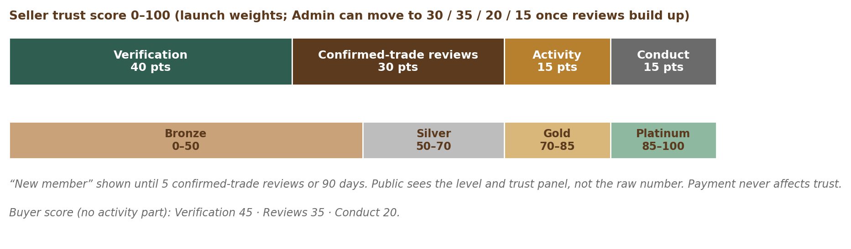
Figure 10 — Trust score components and levels

7.1 Trust score formula (defaults, all configurable)
Component | Points | How it is earned
Verification | 40 | Email + phone 5 · identity / business registration 20 · higher-bar documents 10 · all documents current 5
Reviews | 30 | Confirmed-trade reviews only; weighted average with a neutral starting value (~3.5★ worth 5 reviews); last 12 months full weight, older half weight
Activity | 15 | Reply rate (share of enquiries answered within 24 hours) 10 · active in last 30 days 3 · confirmed trades in 12 months 2 (automatic replies do not count)
Conduct | 15 | Starts at 15; deductions only for moderator-upheld issues: spam −2 (6 months), misrepresentation −5 (12 months), scam −15 plus suspension review (12 months), forged document → 0 until Admin clears

- Levels: New member (until 5 confirmed-trade reviews or 90 days, whichever is later) · Bronze below 50 · Silver 50–69 · Gold 70–84 · Platinum 85+.
- Phased weights: 40 / 30 / 15 / 15 at launch; Admin may switch to 30 / 35 / 20 / 15 once enough reviews exist (about 6 months), with the change published.
- Buyers: Verification 45 · Reviews 35 · Conduct 20.
- Separate from trust: origin documents stay at listing level; payment never affects trust.

7.2 Safety controls at a glance
Risk | Control | Where
Fake businesses | Business verification, registry checks, identity check with live selfie, enhanced check for high-risk sellers, document expiry | Module 3
Advance-payment scams | Message caps, blocked contact/bank details for new accounts, payment-word warnings, 4-hour scam response | Modules 9, 12
Fake or blended oil | Purity declaration, banned claims, lab report option, strikes for false declarations | Modules 5, 12
Illegal wild wood | “Wild” claims banned, plantation-only export, CITES scope per item, origin documents | Modules 4, 5, 6
Fake documents | Completeness review, forgery reports, conduct score to zero | Modules 6, 10
Fake reviews | Confirmed-trade-only reviews, double-blind, network and incentive bans | Module 10
Opportunity / investment misuse | Allowed types only, banned structures (pooling, returns, buy-back, fractional, securities), moderator checklist, enquiry needs ID or business check, not search-indexed, legal notice | Modules 5, 12

8. Domestic vs Export & Compliance in the Product

8.1 Domestic and export trade
Aspect | Domestic | Export (cross-border)
Listing trade scope | Domestic only or Both | Export available or Both
Origin at listing | Origin declaration for raw wood, chips, powder, oil (state/district, plantation-grown, state documents where required) | Same, plus export credentials; DFO Certificate of Legal Possession at deal time
Credentials at listing | Business verification and state documents as configured | Plus export credentials (e.g. IEC, cultivated-origin eligibility)
CITES | Not applicable | Per-shipment CITES permit is the seller’s duty at deal time
India export policy | — | Plantation-origin only, within DGFT quotas
Requirement matching | Sellers in the poster’s country | Export-enabled sellers in any country
Search | Default for local buyers | “Available for export” filter; default for overseas buyers
Currency | INR (India) / USD (others) | Listing currency; guide price in viewer’s currency only

8.2 Legal and data-protection requirements
ID | Requirement | Priority | Release
PRD-CMP-001 | Intermediary obligations (IT Rules 2021 as amended 2026): published Terms and policies; Grievance Officer name and contact [TBC: Grievance Officer]; every complaint acknowledged automatically (within 24 hours) and resolved within 7 days; complaints about unlawful content acted on within 36 hours (daily on-call, including Sunday); court and government orders within 3 hours, 24×7; legal timers count calendar hours (PRD-MOD-005). | Must | R1
PRD-CMP-002 | Privacy notice and consent records under the DPDP Act 2023 and Rules 2025; separate consent for optional processing and marketing. | Must | R1
PRD-CMP-003 | User rights: access, correction, deletion and grievance, with tracked requests. | Must | R1
PRD-CMP-004 | Personal-data breach process: intimation to the Data Protection Board and affected users without delay, and a detailed report to the Board within 72 hours; CERT-In reporting within 6 hours. | Must | R1
PRD-CMP-005 | Record of personal data sent outside India (e.g. AI or email providers), with provider and purpose. | Must | R1
PRD-CMP-006 | Personal-data processing logs kept for at least 1 year. | Must | R1
PRD-CMP-007 | Written data retention and deletion schedule per data type; data deleted or anonymised when its purpose ends, except where law requires it to be kept. | Must | R1
PRD-CMP-008 | R2 is built to meet the DPDP obligations that apply from 13 May 2027 (notice, consent, rights, security, breach, retention). | Must | R2
PRD-CMP-009 | Seller details shown as required where individual buyers are served (legal name, location, grievance route), as confirmed by counsel. | Must | R1
PRD-CMP-010 | Standard units with conversions to support fair quantity declarations; the seller remains responsible for packaging labels. | Must | R1
PRD-CMP-011 | Opportunity listings carry the standard notice: advertised offer only, no investment scheme, no promised returns, buyer due diligence required. | Must | R1
PRD-CMP-012 | Buyer due-diligence notice on listings and in Terms: documents are “on file — reviewed, not authenticated” (reviewed for completeness only). | Must | R1

9. Monetisation Structure
The product supports the five revenue streams in the BRD & Business Plan (Section 8.1), with 0% commission always. Final prices and allowances are set in the Monetisation module; the structure is below.
Revenue stream | In the product | Timing
Subscriptions | Free plan and paid tiers per selling role (Module 11, Part A) | R2
Advertising (Ad Engine) | Sponsored listings, featured storefronts, banners (Module 11, Part B) | R2
Paid services | Assisted listing, bulk listing help, featured content, sold as one-off items (Module 11, Part C) | From R2
Partner fees | Partner programme listing and partnership fees | Phase 2 for paid fees
Data & insights, events | Aggregated, anonymised price trends and demand insights; webinars and trade events | Phase 2
Commission | None — 0% commission is permanent | Never

Plan dimension | Varies by tier | Notes
Live listing cap | Yes | Surplus returns to draft on downgrade
Buy-lead responses per month | Yes | Receiving leads is free; responding uses the allowance
Storefront customisation and analytics | Yes | Standard storefront free for all
Support speed | Yes | 24 h Free · 8 h paid; phone callback for paid
Ad credits | Yes | Credits usable in the Ad Engine
Trust, ranking weight, review display | Never | Paying never affects these
Billing currency | INR / USD | India-based vs others

Draft price range from the business plan: about ₹999 per month (entry paid plan) to about ₹20,000 per month (top Company plan); USD pricing for international accounts.

10. AI Features & Rules
AI feature | Release | Human control
AI search (natural language, synonyms, multilingual, semantic) | R2 | Results explainable; ranking weights published
AI moderation assist | R2 | Flags only; moderator decides
AI listing assistant | R1 (Should) | Seller approves every suggestion
Smarter requirement matching (meaning-based) | R2 | Poster filters always respected
AI help assistant | R2 | Hands over to a person
Chat reply and quotation drafts, translation, summaries | Phase 2 | Seller approves; never automatic
Recommendations, price insights, buyer/seller AI agents | Phase 2+ | Human approval for any action

ID | Requirement | Priority | Release
PRD-AI-001 | All AI calls go through the AI gateway, which is part of Module 1 (Platform Foundation); it allows switching provider, controls cost and logs every request and action. | Must | R1
PRD-AI-002 | Data is kept structured and APIs have scoped permissions so AI agents can be added later safely. | Must | R1
PRD-AI-003 | Vector (semantic) search support alongside keyword search. | Must | R2
PRD-AI-004 | AI-generated text shown to users is labelled; users can edit or reject it. | Must | R1
PRD-AI-005 | No fully automatic AI replies to other users; bots never send contact, bank or payment details. | Must | R1
PRD-AI-006 | Personal data and AI (tiered rule): Restricted data (ID and document numbers, verification documents, photo location, passwords, keys, audit log), images of IDs and selfies, and contact details are never sent to AI providers (one exception: the text of a foreign-language verification document may be translated for the reviewer with ID and document numbers removed first, PRD-ROL-027); other personal data is sent only when the purpose needs it, minimised, and only to a provider listed in the cross-border register; an India-hosted model is preferred. | Must | R1
PRD-AI-007 | AI never verifies, bans, approves documents or changes trust by itself. | Must | R1
PRD-AI-008 | If AI tools that create or alter images, audio or video are added, their output carries a clear “AI-generated” label and safeguards required by the IT Rules 2026. | Must | R1

11. Non-Functional Requirements
ID | Requirement | Priority | Release
PRD-NFR-001 | Search results within 1 second (95th percentile). | Must | R2
PRD-NFR-002 | Main pages usable within 2.5 seconds on a 4G connection in India and within 3 seconds from the Gulf and South-East Asia. | Must | R1
PRD-NFR-003 | Availability 99.0% per month in R1 and 99.5% from R2, excluding announced maintenance (Wed 02:00–04:00 IST, 48 hours’ notice). | Must | R1
PRD-NFR-004 | Year-1 capacity: about 100,000 listings, 50,000 users and 25 searches per second at peak, with 3× headroom. | Must | R2
PRD-NFR-005 | Recovery point objective 5 minutes (region loss ≤ 1 minute); restore within 24 hours in R1 and 8 hours from R2; quarterly restore drills and a yearly region failover drill (NFR, Section 5); multi-zone hosting in Mumbai with a warm standby database in Hyderabad (a few seconds behind) and backups copied to Hyderabad. | Must | R1
PRD-NFR-006 | Encryption in transit (TLS) and at rest; secrets in a managed vault. | Must | R1
PRD-NFR-007 | Security to OWASP ASVS 5.0 level 2; dependency and vulnerability scanning in the build pipeline; VAPT by a CERT-In empanelled auditor before R1 and yearly. | Must | R1
PRD-NFR-008 | Accessibility: WCAG 2.2 AA for public, user and Admin pages and the apps. | Must | R1
PRD-NFR-009 | Browsers: latest two versions of Chrome, Safari, Edge and Firefox; phones Android 10+ with 2 GB RAM and iOS 15+; responsive from 360 px mobile width to desktop; usable on slow 3G. | Must | R1
PRD-NFR-010 | Languages: English at launch; multilingual-ready (translation store, right-to-left layout). Order after launch: Arabic; then Hindi, Assamese and Bengali; then Chinese and Japanese. | Must | R1
PRD-NFR-011 | All numbers, dates and currencies formatted for the user’s locale. | Must | R1
PRD-NFR-012 | Observability: logs, metrics and alerts for all services; audit log 7 years; security logs at least 180 days; personal-data processing logs at least 1 year. | Must | R1
PRD-NFR-013 | Speed at the 75th percentile: Largest Contentful Paint ≤ 2.5 s, Interaction to Next Paint ≤ 200 ms, Cumulative Layout Shift ≤ 0.1; API reads ≤ 300 ms and writes ≤ 800 ms (95th percentile); OTP delivered within 30 seconds for 95%. Full targets, legal register and launch gates: NFR, Security & Compliance document. | Must | R1

12. Release Plan
Release | Timing | Users | Scope (modules)
R1 — Public web launch | ~Month 3 | Everyone, worldwide (open sign-up); farmers mostly through field agents. The BRD sizes (100–200 sellers, about 100 farmers, about 1,000 listings) are targets, not caps; verification review capacity paces growth. An Early users programme of 50–70 invited users gives structured feedback | 1 Foundation · 2 Identity · 3 Roles & verification (incl. field agents) · 4 Taxonomy · 5 Listings (bulk upload, grading, trade fields) · 6 Documents (basic) · 7 Search (basic) & storefronts (public browsing) · 9 Register interest (enquiry-lite) · 12 Moderation · 13 Notifications (email, SMS, voice-call codes, WhatsApp, in-app) · 14 Basic role dashboards (M03: buyer, seller-side, farmer) · 15 Admin Ops (basic) · 17 Content & legal · 18 Monitoring (basic)
R2 — Full web release | ~Month 6–7 | All users | 8 Requirements & buy leads · 9 Messaging & quotations · 10 Reviews & trust · 11 Monetisation · 14 Dashboards · 16 Configuration console · 18 Analytics · AI search · 6 Traceability & document requests · 7 Buyer tools & paid storefronts · Partner programme
R3 — Mobile apps | ~Month 8–9 | All users | 19 iOS & Android apps · push notifications

12.1 Launch checks
The go / no-go launch gates for R1, R2 and R3 are kept in one list only: NFR, Security & Compliance document, Section 11 (signed by the product owner, tech lead and counsel, PRD-TST-004). Because R1 is a public launch, the full VAPT (PRD-TST-003) and the counsel answers on EU / UK GDPR (C9) and the EU Digital Services Act (C14) are needed before R1 (Section 15).

13. Out of Scope for V1
Phase | Items
Phase 2 | Team accounts (Company) · Retail listing mode [TBC: trigger] · AI chat drafts, auto-translation, summaries · recommendations and price insights · price-drop / back-in-stock alerts · private buyer notes · paid partner fees; valuers, logistics, inspection partners · “Independently valued” label · paid lab grading · mediation / ODR referral · ambassador programme · embeddable “Verified on OudhTrade” badge · account managers · data & insights products
Phase 3 | Related fragrance raw materials (sandalwood, attars, essential oils, resins, frankincense) · white-label options
Never | Commission on deals · payments or escrow between users · investment schemes or promised returns

14. Product Success Measures
North-star metric: confirmed trades per month — only full trades (not samples) that both sides confirmed with “We traded”. Sample trades are counted separately; disputed trades and “confirmed (no reply)” trades are counter-metrics (PRD-TRS-011).
Measure (after R2) | Month 6 | Month 12
Verified business sellers | 1,200 | 3,000
Active listings | 15,000 | 50,000+
Registered buyers | 3,000 | 10,000
Monthly enquiries | 2,000 | 8,000
Seller reply rate within 24 h | 70% | 80%
Requirement posts with 1+ response | 50% | 65%
Confirmed trades per month | 100 | 500
Paying sellers | ~150 | ~350 base (500 stretch)
Upheld scam reports (share of active accounts) | < 1% | < 0.5%
Listing review within service target | ≥ 95% | ≥ 95%
Search response within 1 s (P95) | ≥ 95% | ≥ 95%

Business KPIs and financial targets are defined in the BRD & Business Plan.

15. Open Items & Assumptions
# | Open item | Decided in
1 | Listing file: sub-categories and items; Farmer categories and limits | Listing / taxonomy module tuning
2 | Public price display rule (price shown vs “Sign in to see price”) | Listing module tuning
3 | Final plan tiers, prices, allowances; Founding Seller N, free period and discount | Monetisation tuning
4 | Final role-category permissions, including Opportunities | Taxonomy module tuning
5 | Trigger for Phase 2 Retail mode | After public launch
6 | Grievance Officer, registered office, support email, Terms effective date | Before R1
7 | Counsel (C1): Opportunities allowed types, banned structures and legal notice wording (SEBI CIS, BUDS Act, Companies Act) | Before R1
8 | Counsel (C2): confirm the Consumer Protection (E-Commerce) Rules and 2026 amendment (from 1 Jan 2027) do not apply to a listing-only platform | Before R2
9 | Counsel (C3): Wildlife (Protection) Act Schedule IV — registration duties for nurseries holding living Aquilaria plants | Before R1
10 | Counsel (C4): whether OudhTrade must register with FSSAI as an e-commerce food business for food listings | Before R1
11 | Counsel (C5): RERA, state land laws and FEMA (agricultural land) for land and plantation listings | Before R1
12 | Counsel (C6): UAE and Saudi data-protection laws, so Gulf sellers can onboard normally from R1 | Before R1
13 | Counsel (C7): sanctioned-country list for sign-up blocking | Before R1
14 | Counsel (C8): Legal Metrology Act 2009 (Section 11) — metric prices with traditional units as helpers; Packaged Commodities Rules 2011 declarations for packed incense and attar | Before R1
15 | Counsel (C9): EU / UK GDPR and foreign privacy notice or local representative for overseas users (the GDPR notice is live at R1) | Before R1
16 | Counsel (C10): final retention period per data type | Before R1
17 | Counsel (C11): CERT-In time-source requirement for cloud servers | Before R1
18 | Counsel (C12): seller details to show where individual buyers are served | Before R1
19 | Counsel (C13): whether OudhTrade could be notified as a Significant Data Fiduciary, and the scope of the data protection impact assessment (DPIA) | Before R2
20 | Counsel (C14): whether the EU Digital Services Act applies, and the minimum duties if it does (notice-and-action and trader details are switched on at R1) [TBC: C14 — DSA Art. 30–31 may require a trader’s contact details to be shown to EU consumers; until counsel answers, contacts stay private (PRD-ROL-010)] | Before R1
21 | Counsel (C15): which sanctions lists to screen business and export sellers against, and how often (R2) | Before R2
22 | Counsel (C16): legal time limits for data-request replies (DPDP, GDPR, UAE, Saudi) | Before R1
23 | Counsel (C17): US INFORM Consumers Act — seller-information duties (likely not applicable: no payments on OudhTrade; applied from R1 where counsel says it applies) | Before R1
24 | Counsel (C18): Aadhaar — UIDAI registration and approval as an offline verification-seeking entity (OVSE) for Aadhaar OTP e-KYC through a UIDAI-licensed provider, and the ban on keeping Aadhaar photocopies | Before R1
25 | Counsel (C19): GST — whether OudhTrade is an e-commerce operator under GST, and whether sellers need GST registration to sell to other Indian states | Before R1
26 | Counsel (C20): DPDP Rules timeline — confirm the main-duty date (13 May 2027) and any change to a shorter timeline | Before R1
27 | Counsel (C21): agarwood export rules — DGFT export quota for plantation-origin agarwood (Notification 52/2024-25) and the CITES CoP20 (2025) outcome on agarwood | Before R2
28 | Listing badges “Origin documented”, “Tree registered” and “Lab tested”: whether to add them, and their rules | Module 6 design

15.1 Assumptions
- The in-house team delivers R1 in about 3 months and R2 by about month 6–7.
- Third-party services are used where suitable: payment gateway, SMS/email/WhatsApp providers, helpdesk, search engine, AI providers, malware scanning.
- Current CITES and Indian export rules remain broadly stable during V1.

15.2 Module design inputs
Items each module must design in its own documents. They are inputs to module tuning, not new PRD requirements.
Module | Item to design
M02 Identity & Security | Account takeover protection: SIM-swap risk of OTP-only sign-in, cooling-off after a phone or email change, new-device checks, credential-stuffing monitoring — Covered in M02 (PRD-IDN-002, 016, 017, 018, 025)
M02 Identity & Security | DPDP request deadlines — Covered in M02 (PRD-IDN-021)
M02 Identity & Security | What happens when a minor is found — Covered in M02 (PRD-IDN-022)
M02 Identity & Security | Restricted-party screening at sign-up — Covered in M02 (PRD-IDN-013, 023, 024)
M03 Roles, Profiles & Verification | KYC / anti-money-laundering (AML) level for high-value sellers, Opportunities, and land and business sales — Covered in M03 (PRD-ROL-028, enhanced check)
M04 Taxonomy & Compliance Rules | Grade mapping across Indian, Arabic, Vietnamese and Japanese trade grades
M04 Taxonomy & Compliance Rules | CITES annotation #14: which finished products are exempt
M05 Listings | Treated / impregnated / weighted declaration for chips and wood
M05 Listings | Oil diluent fields
M05 Listings | Lab report fields: method (e.g. GC-MS), NABL / ISO 17025 lab, date, lot link
M06 Origin & Trade Documents | Importing-country rules: EU import permit, US Lacey Act / USFWS, China, Japan
M06 Origin & Trade Documents | Phytosanitary certificate, certificate of origin, quota status; personal-effects limits
M05 Listings / M06 Origin & Trade Documents | Land and plantation proof on listings (land record, lease, community-land certificate, family-land declaration, proof of land rights for land offers), plantation and origin proofs and lab reports — not asked at farmer onboarding (PRD-ROL-017, 028); a field agent adds them to a farmer’s listing under delegation; a farm-visit report can be attached as proof to listings from that farm
M05 Listings / M07 Search & Discovery | R3: show “Away until {date}” on listings and search results (PRD-ROL-045, planned for R3)
M07 Search & Discovery | Multilingual synonyms from trade terms; Arabic, Chinese and Japanese search
M07 Search & Discovery | Relevance test set; embeddings table (search.listing_embeddings)
M09 Messaging & Quotations | Sample shipments abroad need CITES and phytosanitary papers (warning and guidance)
M09 Messaging & Quotations | Incoterms guidance on quotations; safe-payment guidance (letter of credit / escrow outside OudhTrade)
M09 Messaging & Quotations | R3: automatic reply to enquiries while a seller is away, and the reply measure paused while away (PRD-ROL-045, planned for R3). R1: design of the “business buyers only” / “verified buyers only” enquiry filter (PRD-ROL-008)
M11 Monetisation | Foreign VAT on digital services (UAE, Saudi, EU OSS, Singapore OVR)
M12 Moderation & Compliance Operations | IT Rules: 24-hour removal of non-consensual intimate images; CSAM reporting (POCSO); keep removed content and records 180 days; takedown statistics / transparency report
M12 Moderation & Compliance Operations | Arabic-language moderation and GCC weekend cover
M13 Notifications | Email deliverability operations: sender domains, bounces, complaints
M17 Content & Legal | AI disclosure for the help assistant; AI section in the privacy notice; ranking explanation
M17 Content & Legal | Privacy contact page, cookie inventory, Global Privacy Control signal, accessibility statement page
M19 Mobile Apps | App attestation (Play Integrity / App Attest); push credential handling; independent app penetration test before R3

Appendix A — Glossary
All terms used in this document are defined in the OudhTrade Glossary (project document in 00 Project Documents), which also sets the one-meaning rule for words that are easy to mix up.

Appendix B — Requirement Summary
Number of PRD-level requirements by area. Each is expanded in the module FRS and traced in the traceability matrix.
Prefix | Area | Requirements
PRD-GEN | Platform-wide rules | 15
PRD-FND | M1 Platform Foundation | 16
PRD-IDN | M2 Identity & Security | 39
PRD-ROL | M3 Roles, Profiles & Verification | 46
PRD-TAX | M4 Taxonomy & Compliance Rules | 9
PRD-LST | M5 Listings | 24
PRD-ORG | M6 Origin & Trade Documents | 13
PRD-SRC | M7 Search & Discovery | 12
PRD-RQM | M8 Requirements & Buy Leads | 12
PRD-MSG | M9 Messaging & Quotations | 16
PRD-TRS | M10 Reviews & Trust | 11
PRD-MON | M11 Monetisation | 17
PRD-MOD | M12 Moderation & Compliance Operations | 12
PRD-NTF | M13 Notifications | 7
PRD-DSH | M14 Dashboards | 5
PRD-OPS | M15 Admin: Operations Console | 6
PRD-CFG | M16 Admin: Configuration Console | 5
PRD-CNT | M17 Content & Legal | 11
PRD-ANL | M18 Analytics & Monitoring | 5
PRD-APP | M19 Mobile Apps | 5
PRD-TST | M20 Testing & Go-Live | 5
PRD-CMP | Legal & data protection | 12
PRD-AI | AI rules | 8
PRD-NFR | Non-functional | 13
 | Total | 324

Appendix C — Working Sub-Category List
Working list of sub-categories for reference during listing-module tuning. It is Admin-managed data and will be confirmed or changed with the listing file [TBC: listing file].
Category | Sub-categories (working list)
1. Agarwood Products | Raw agarwood · Chips · Powder, dust & flakes · Oil & extracts · Incense products · Tea, leaf & wellness · Cosmetics & skincare · Fragrance & perfumery · Carved, collectible & ritual items · Accessories · Gift & luxury sets · By-products & secondary materials · Other
2. Nursery & Plantation | Planting materials · Seed & propagation · Cultivation inputs · Other
3. Inoculation | Inoculation products · Inoculation tools & equipment · Other
4. Processing, Distillation & Manufacturing | Distillation · Processing · Manufacturing inputs · Packaging & labelling · Laboratory & testing equipment · Other
5. Services | Trade & sourcing · Technical services · Training & advisory · Certification & compliance · Import & export agents · Other
6. Agarwood Opportunities | Standing trees for sale (outright) · Land or plantation for sale or lease · Business or unit for sale or lease · B2B partnership (one named counterparty) · Franchise & technology licence. Removed from the old list: tree adoption / sponsorship, managed plots with deed, company equity, Other.

